**B.M.S. COLLEGE OF ENGINEERING BENGALURU**

Autonomous Institute, Affiliated to VTU



Lab Record

**Object-Oriented Modeling**

*Submitted in partial fulfillment for the 5th Semester Laboratory*

Bachelor of Engineering

in

Computer Science and Engineering

*Submitted by:*

**VISHWAS H KUMAR**

1BM22CS338

Department of Computer Science and Engineering

B.M.S. College of Engineering

Bull Temple Road, Basavanagudi, Bangalore 560 019

Mar-June 2024

**B.M.S. College of EngineerinG**

**DEPARTMENT OF COMPUTER SCIENCE AND ENGINEERING**



***CERTIFICATE***

This is to certify that the Object-Oriented Modeling (22CS5PCOOM) laboratory has been carried out by Vishwas H Kumar (1BM22CS338) during the 5th Semester Oct 24-Jan2025.

Signature of the Faculty Incharge:

Anusha S

Department of Computer Science and Engineering

B.M.S. College of Engineering, Bangalore

**Table of Contents**

|  |
| --- |
| 1. Hotel Management System |
| 1. Credit Card Processing |
| 1. Library Management System |
| 1. Stock Maintenance System |
| 1. Passport Automation System |

1. **Hotel Management System**

**Problem Statement**: Hotels often face challenges in managing their daily operations efficiently, such as handling reservations, managing room availability, billing, staff management, and customer service. Traditional systems or manual methods are time-consuming, error-prone, and do not scale well with growing customer demands.

**1.1 SRS-Software Requirements Specification**

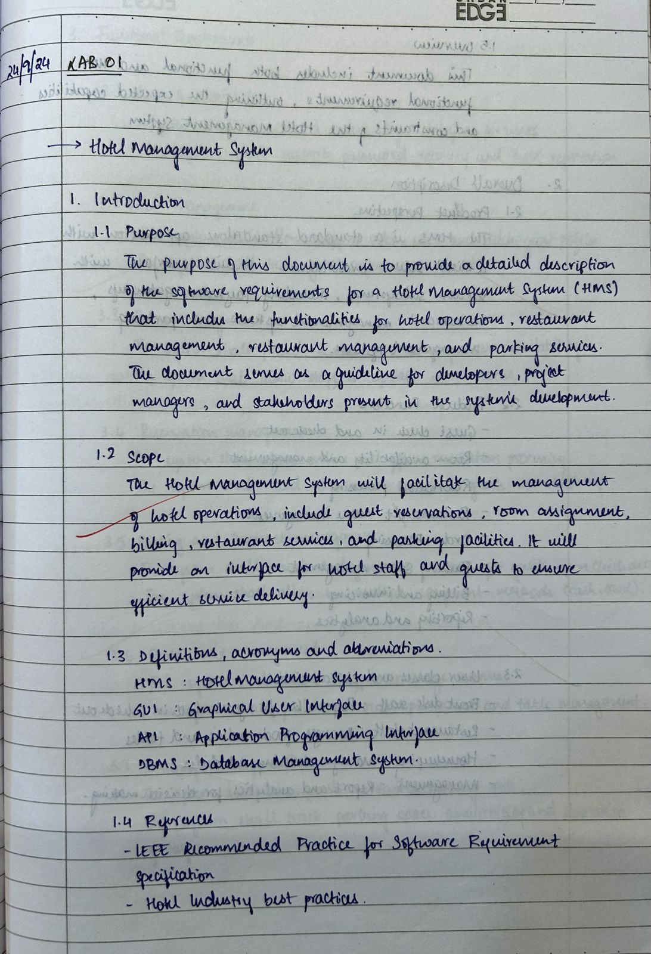

**Fig 1.1.1**

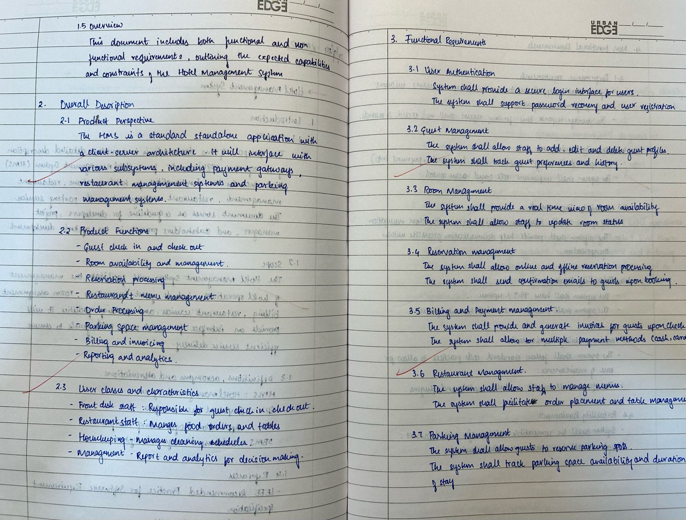

**Fig 1.1.2**

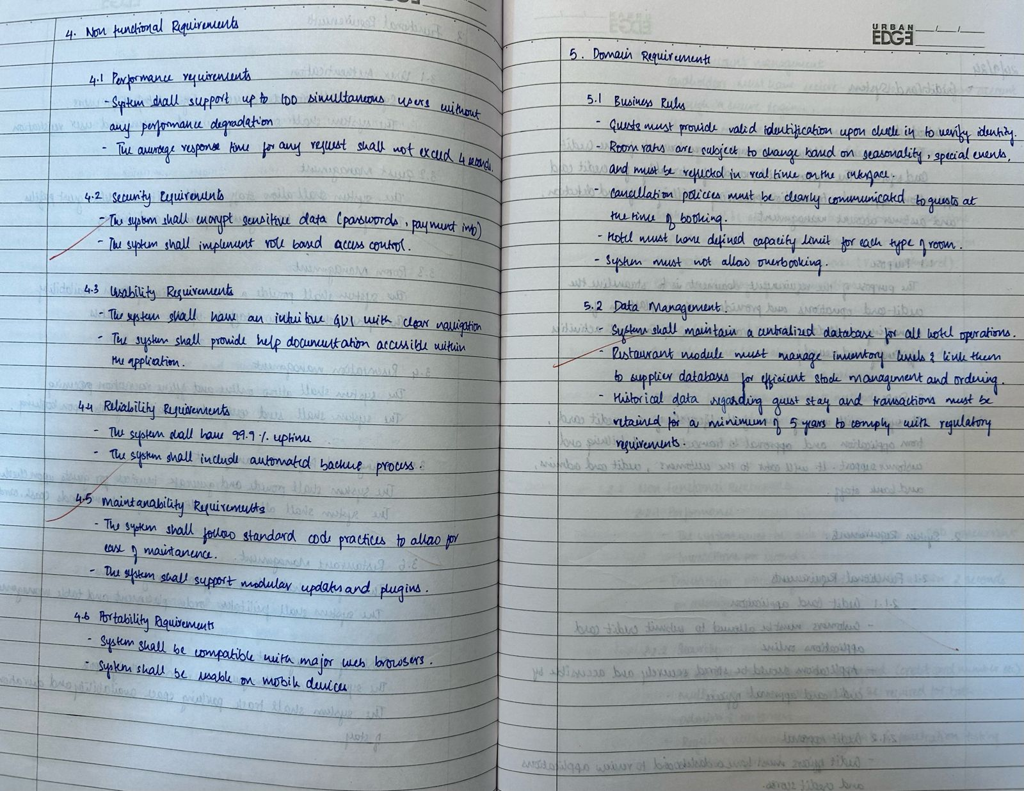

**Fig 1.1.2**

* 1. **Class Diagram**

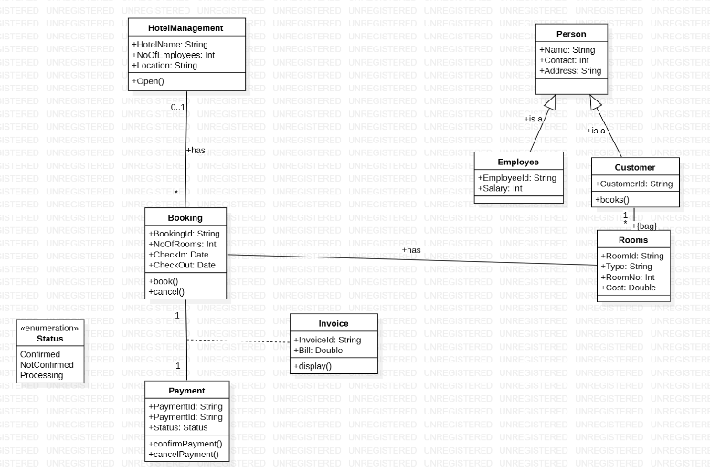

**Fig 1.2.1: Simple Class Diagram**

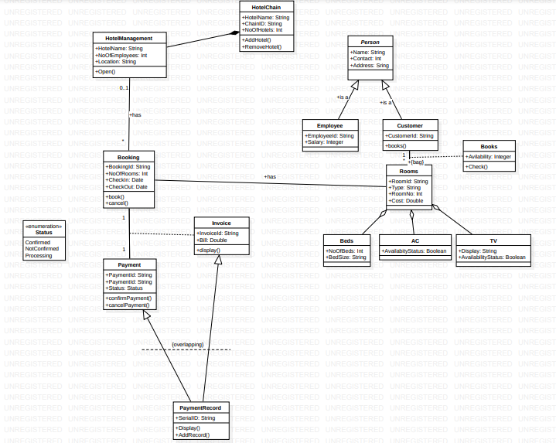

**Fig 1.2.2: Advanced Class Diagram**

The class diagram represents a **Hotel Management System**, outlining key entities and their interactions. Below are the major components:

**Core Classes:**

* **HotelManagement:** Manages high-level operations with attributes like HotelName, NoOfEmployees, and Location. The Open() method initializes hotel operations.
* **Booking:** Handles reservations with attributes like BookingId, NoOfRooms, CheckIn, and CheckOut, and methods book() and cancel(). Linked to **Customer** and associated with **Rooms**.
* **Rooms:** Represents hotel rooms with properties such as RoomId, Type, RoomNo, and Cost. Aggregates **Beds** to define room structure.
* **Payment:** Tracks payment details using attributes like PaymentId and Status (enumeration: Confirmed, NotConfirmed, Processing) and methods confirmPayment() and cancelPayment().
* **Invoice:** Stores billing information (InvoiceId, Bill) and generates an invoice view using the display() method.

**Specialized Entities:**

* **Person:** Base class for **Employee** and **Customer**.
  + **Employee:** Adds EmployeeId and Salary.
  + **Customer:** Includes CustomerId and is linked to **Booking**.
* **HotelChain:** Represents a chain of hotels with attributes HotelName, ChainID, and NoOfHotels. Methods AddHotel() and RemoveHotel() manage the chain.

**Utility Classes and Enumeration:**

* **Beds, AC, TV:** Support room features, e.g., **Beds** defines NoOfBeds and BedSize.
* **Status:** Enumerates payment states (e.g., Confirmed, NotConfirmed).
  1. **State Diagram**

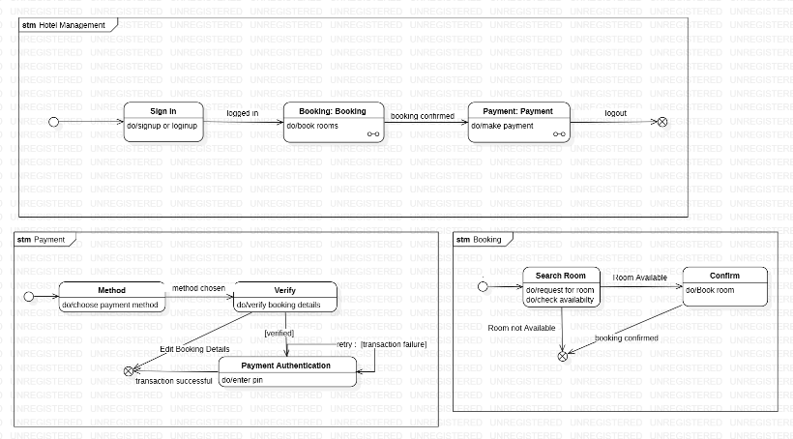

**Fig 1.3.1: Simple State Machine Model**

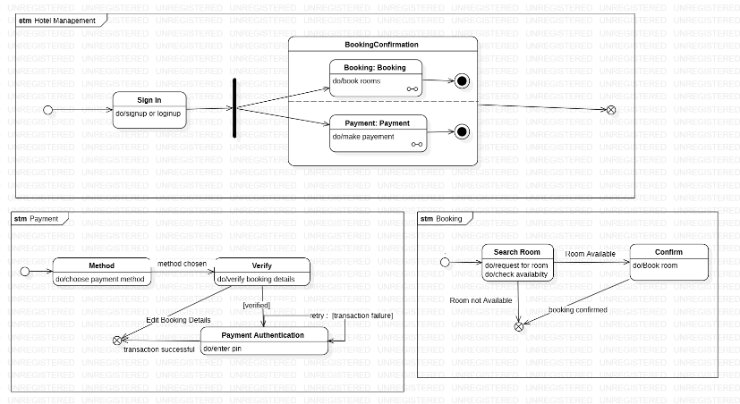

**Fig 1.3.2: Advanced State Machine Model**

The state machine diagrams illustrate the dynamic behavior and transitions between states in the **Hotel Management System**. The key models include the **Hotel Management System**, **Payment Process**, and **Booking Process**.

**State Machine: Hotel Management**

* **Initial State:** The process begins at the **Sign In** state.
* **Sign In:** Handles user authentication, allowing guests or employees to log in or sign up.
* **BookingConfirmation:** A composite state with two parallel operations:
  + **Booking:** Performs actions to doBook rooms for confirmed reservations.
  + **Payment:** Executes doMake payment to complete the booking process.
* **Completion:** The final state is reached after successful booking and payment.

**State Machine: Payment Process**

* **Initial State:** Begins with selecting a **Payment Method** (e.g., card, cash, digital wallet).
* **Verify:** Confirms booking details for accuracy.
  + **If verification fails:** Users can edit booking details and retry.
* **Payment Authentication:** Requires entering a PIN or equivalent credentials for payment authorization.
  + **Transaction Success:** Proceeds to the final state, marking payment completion.
  + **Transaction Failure:** Redirects users to retry or cancel the payment.

**State Machine: Booking Process**

* **Initial State:** Begins with the **Search Room** action.
  + **Search Room:** Processes the user’s room availability request.
    - **If Room Not Available:** The search ends, or alternatives are suggested.
* **Room Available:** Transitions to the **Confirm** state, where booking details are finalized.
  + **Confirm:** Executes the doBook room action, completing the reservation.
* **Final State:** The process concludes when the booking is confirmed.
  1. **Use Case Diagram**

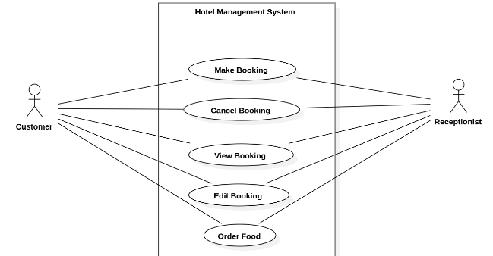

**Fig 1.4.1: Simple Use Case Diagram**

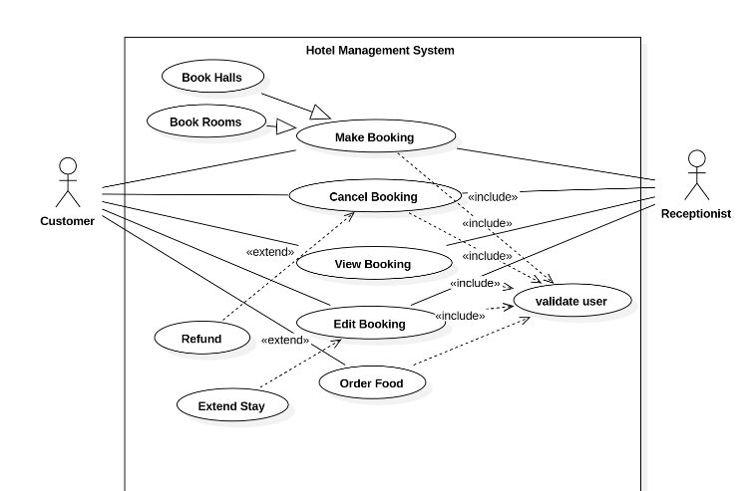

**Fig 1.4.2: Advanced Use Case Diagram**

This use case diagram illustrates the interactions between actors (Customer and Receptionist) and the hotel management system. Key use cases and their relationships are outlined below:

**Actors:**

1. **Customer:** Interacts with the system to manage bookings and related activities.
2. **Receptionist:** Handles administrative tasks and validates user actions.

**Use Cases:**

1. **Book Rooms:** Customers can book rooms for their stay.
2. **Book Halls:** Customers can reserve halls for events or meetings.
3. **Make Booking:** A general use case encompassing room or hall bookings.
4. **Cancel Booking:** Allows the cancellation of bookings by the customer or receptionist.
   * **Includes:** Validate user to ensure authorization for cancellation.
5. **View Booking:** Customers can view their current bookings.
6. **Edit Booking:** Enables customers to modify booking details.
   * **Includes:** User validation to confirm authorization.
7. **Order Food:** Lets customers order food during their stay.
   * **Extends:** Edit Booking for adding meal preferences to existing reservations.
8. **Extend Stay:** Allows customers to prolong their stay at the hotel.
   * **Extends:** Edit Booking for extending reservation duration.
9. **Refund:** Processes refunds for canceled bookings.
   * **Extends:** Cancel Booking when applicable.
   1. **Sequence Diagram**

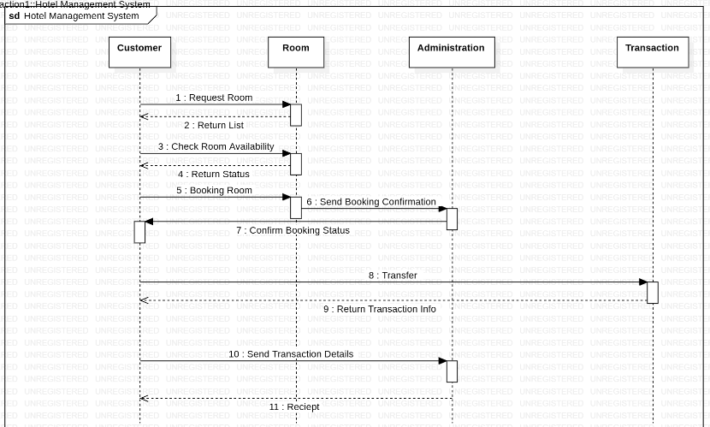

**Fig 1.5.1: Simple Sequence Diagram**

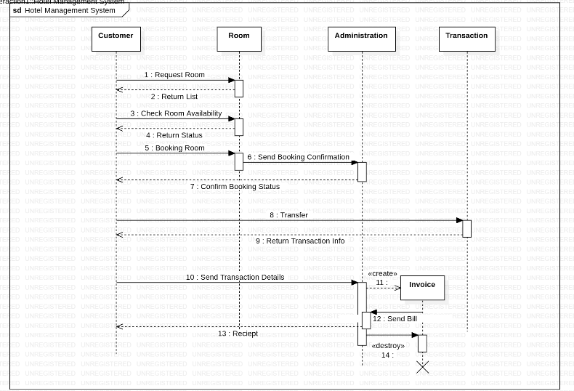

**Fig 1.5.2: Advanced Sequence Diagram**

* **Request Room (Customer → Room):** The customer initiates the process by requesting room details.
* **Return List (Room → Customer):** The system provides the customer with a list of available rooms.
* **Check Room Availability (Customer → Room):** The customer selects a room, and the system verifies its availability.
* **Return Status (Room → Customer):** The system informs the customer of the room's availability.
* **Booking Room (Customer → Room):** If available, the customer books the room.
* **Send Booking Confirmation (Room → Administration):** The room system communicates the booking to the administration for approval.
* **Confirm Booking Status (Administration → Customer):** The administration notifies the customer of the confirmed booking.
* **Transfer Payment (Customer → Transaction):** The customer proceeds with payment via the transaction system.
* **Return Transaction Info (Transaction → Administration):** The transaction system sends payment details to the administration.
* **Send Transaction Details (Administration → Customer):** The administration updates the customer with transaction details.
* **Create Invoice (Administration → Invoice):** The invoice system generates a billing invoice for the transaction.
* **Send Bill (Invoice → Customer):** The generated bill is sent to the customer.
* **Receipt (Customer → Invoice):** The customer acknowledges receipt of the bill.
* **Destroy Invoice:** The invoice is destroyed after the process is successfully completed.
  1. **Activity Diagram**

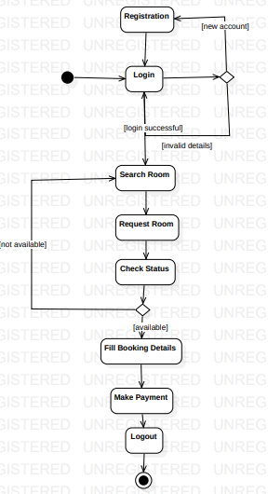

**Fig 1.6.1: Simple Activity Diagram**

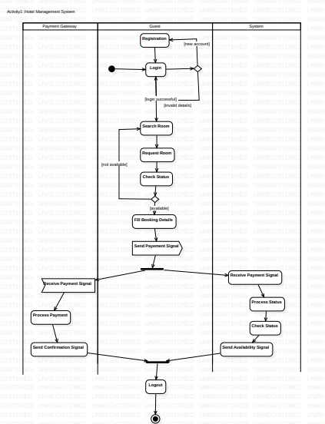

**Fig 1.6.2: Advanced Activity Diagram**

An activity diagram typically represents the workflows within a system, focusing on the sequence of activities and decision points. Here's a breakdown of the activity diagram for the Hotel Management System:

**Start Point:**

* The process begins when a customer initiates an action, such as searching for a room or performing other tasks.

**Key Activities:**

1. **Search for Rooms or Halls:**
   * The customer searches for available options in the system, prompting it to display a list of choices.
2. **Select Room or Hall:**
   * Based on preferences, the customer selects a specific room or hall.
3. **Check Availability:**
   * The system verifies the availability of the selected option for the specified date and time to allow the process to proceed.
4. **Make a Booking:**
   * The customer enters personal and booking details, such as check-in and check-out dates, and confirms the booking request.
5. **Process Payment:**
   * The system transitions to payment processing, where the customer completes the transaction using credit cards, debit cards, or other payment gateways.
6. **Confirm Booking:**
   * Upon successful payment, the booking is confirmed, a notification is sent to the customer, and system records are updated.

**Decision Points:**

* **Is the Room or Hall Available?**
  + *Yes:* The process proceeds to booking.
  + *No:* The customer is prompted to select a different option or modify criteria.
* **Is Payment Successful?**
  + *Yes:* The booking is confirmed.
  + *No:* The customer may retry payment or cancel the process.

**Additional Features:**

* **Cancel Booking:**
  + Customers can cancel bookings, triggering the system to process refunds (if applicable).
* **Order Food or Extend Stay:**
  + Customers may perform additional activities like ordering food or extending their stay, which can be integrated into the workflow.

**End Point:**

* The process concludes when the booking is confirmed, canceled, or a related action (like retrying payment) is completed.

**2. Credit Card Processing System**

**Problem Statement**: Financial institutions and merchants face challenges in securely and efficiently managing credit card transactions. The process involves verifying customer details, processing payments, fraud detection, and ensuring regulatory compliance. An unreliable or inefficient system can lead to transaction delays, increased risks of fraud, and poor customer experience.

**2.1 SRS-Software Requirements Specification**

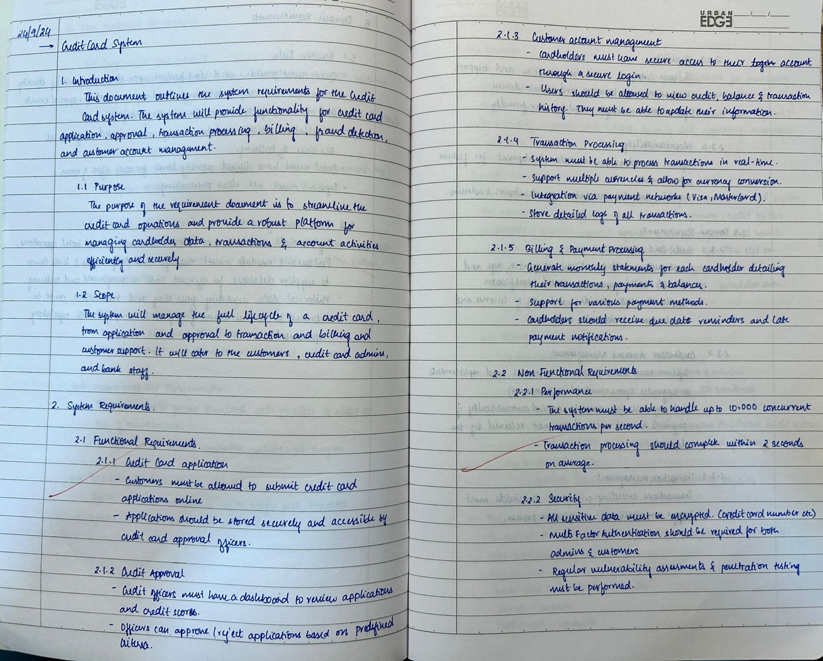

**Fig 2.1.1**

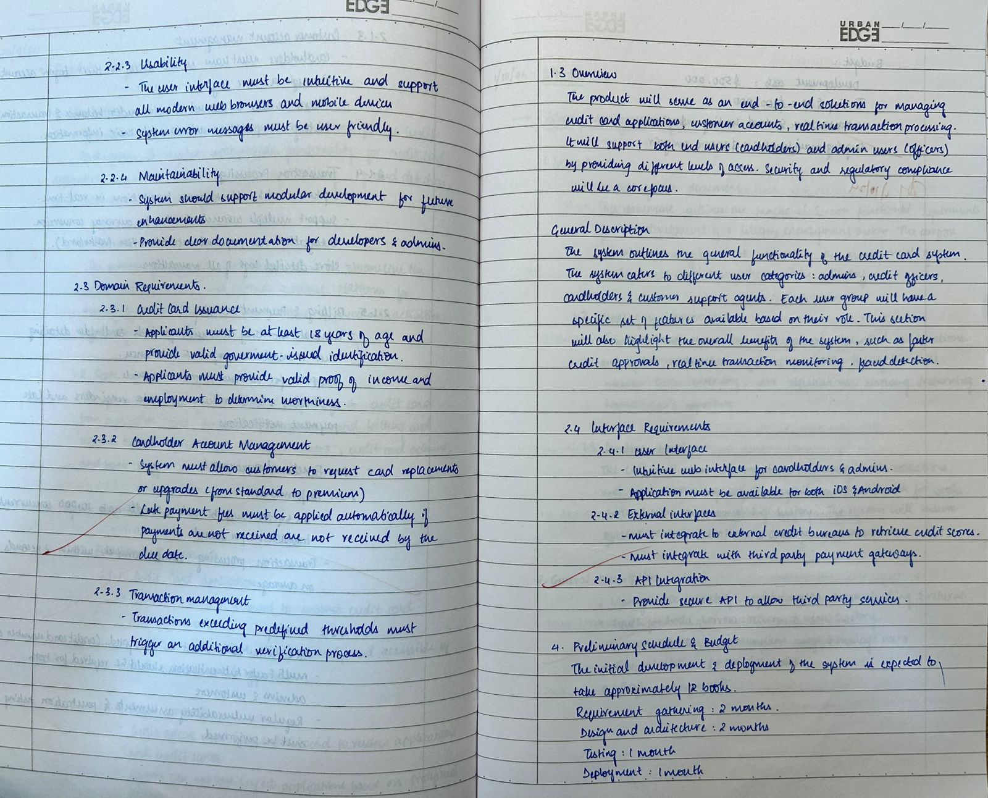

**Fig 2.1.2**

* 1. **Class Diagram**

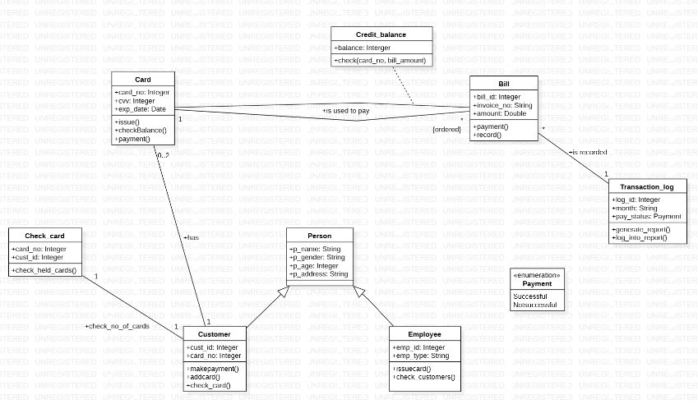

**Fig 2.2.1: Simple Class Diagram**

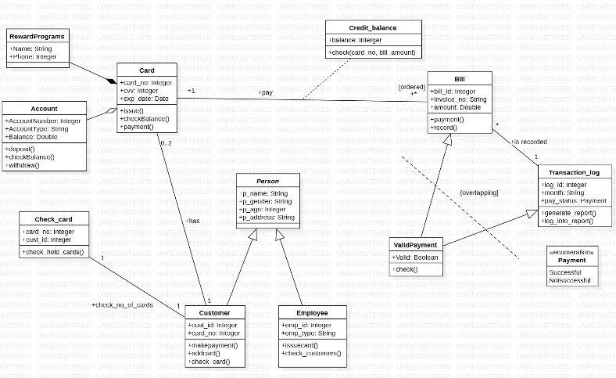

**Fig 2.2.2: Advanced Class Diagram**

The class diagram represents a **Credit Card Processing System** that encompasses key entities and their interactions. Below are the major elements:

**Core Classes:**

* **Customer**: Represents the cardholder with attributes such as cust_id (Customer ID), card_no (Card Number), and methods like:
  + makePayment(): Initiates the payment process.
  + check_card(): Validates the associated card.
* **Card**: Represents the customer's credit card with attributes such as card_no (Card Number), expiry (Expiry Date), and balance. It includes methods like:
  + checkBalance(): Retrieves the card's balance.
  + payment(): Processes a payment.
* **Account**: Manages banking details associated with the customer and card. Attributes include accountNumber, accountType, and balance. Methods:
  + deposit(): Adds funds to the account.
  + withdraw(): Deducts funds.
* **Employee**: Represents staff members involved in the credit card process, with attributes like emp_id (Employee ID) and emp_type (Role). It includes methods such as:
  + check_customers(): Verifies customer details.
  + issueCard(): Issues a new card to the customer.
* **Transaction_log**: Tracks all payment activities with attributes like log_id, month, and pay_status (Successful, NotSuccessful). Methods include:
  + generate_report(): Creates a detailed report of transactions.
* **Bill**: Represents invoices or payment dues with attributes such as bill_id, amount, and invoice_no. It includes the payment() method to settle bills.

**Specialized Entities:**

* **ValidPayment**: Validates payments with attributes like valid (Boolean) and a check() method to confirm payment status.
* **RewardPrograms**: Tracks rewards linked to the customer’s card with attributes such as name and points.

**Utility Classes:**

* **Credit_balance**: Checks the current balance against bills, with methods like:
  + check(card_no, bill_amount): Validates whether sufficient credit is available.
* **Check_card**: Manages card validity with attributes like card_no and cust_id. The check_held_cards() method validates all cards under a customer.

**Relationships:**

* **Inheritance**:
  + Customer and Employee inherit from Person, which serves as a base class with attributes like p_name (Person Name), p_gender, and p_address.
* **Aggregation**:
  + Customer aggregates Card, indicating that a customer may have multiple cards.
  + Card aggregates RewardPrograms, representing card-related rewards.
* **Dependency**:
  + Transaction_log depends on ValidPayment to determine transaction outcomes.
  + Bill depends on Transaction_log for maintaining payment records.
* **Associations**:
  + Customer is associated with Card through a one-to-many relationship.
  + Bill interacts with Card and Credit_balance for payment processing.

**Enumeration:**

* **Payment Status**: Includes statuses like Successful and NotSuccessful to manage and track transaction outcomes effectively.
  1. **State Diagram**

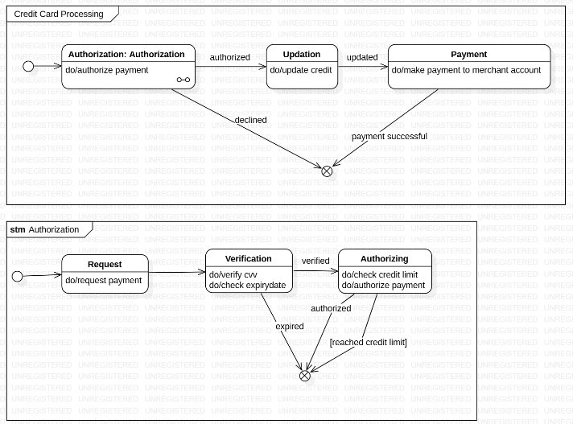

**Fig 2.3.1: Simple State Machine Diagram**

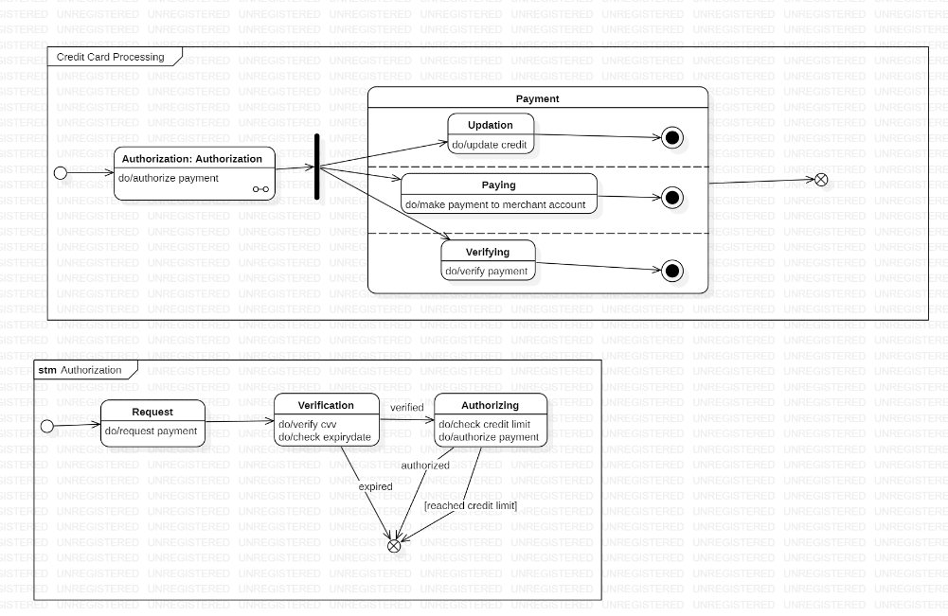

**Fig 2.3.2: Advanced State Machine Diagram**

The state machine diagrams illustrate the dynamic behavior and transitions between states in the **Credit Card Processing System**. The key models include **Credit Card Processing**, **Payment Authorization**, and **Payment Process**.

**State Machine: Credit Card Processing**

* **Initial State**: The process begins at the Authorization state.
* **Authorization**: Represents the initial step of validating the payment request.
  + Actions:
    - do/authorize payment: Initiates the payment authorization process.
* **Payment**: A composite state that integrates three parallel operations:
  + **Updation**: Updates credit information.
    - Action: do/update credit.
  + **Paying**: Processes payment transfer to the merchant account.
    - Action: do/make payment to merchant account.
  + **Verifying**: Confirms payment details.
    - Action: do/verify payment.
* **Completion**: The final state is reached after successful payment processing.

**State Machine: Payment Authorization**

* **Initial State**: Starts with the Request state.
  + Action: do/request payment.
* **Verification**: Ensures the payment credentials (e.g., CVV, expiry date) are correct.
  + Actions:
    - do/verify CVV.
    - do/check expiry date.
  + Transitions:
    - If verified, transitions to the Authorizing state.
    - If expired, moves to a termination state.
* **Authorizing**:
  + Checks credit limit and processes payment authorization.
  + Actions:
    - do/check credit limit.
    - do/authorize payment.
  + Transitions:
    - If authorized, moves to the final state.
    - If credit limit reached, transitions to termination or retry states.
* **Final State**: Reached upon successful payment authorization.

**State Machine: Payment Process**

* **Initial State**: Begins with choosing the Payment Method.
  + Action: do/select payment method (e.g., card, digital wallet).
* **Verify**: Validates the booking or transaction details for accuracy.
  + Transitions:
    - If valid, proceeds to Payment Authentication.
    - If invalid, allows the user to edit details and retry.
* **Payment Authentication**:
  + Requires entering a PIN or equivalent credentials to authorize payment.
  + Transitions:
    - **Transaction Success**: Leads to the final state, marking payment completion.
    - **Transaction Failure**: Redirects users to retry or cancel the payment.
* **Final State**: Reached upon successful completion of the payment
  1. **Use Case Diagram**

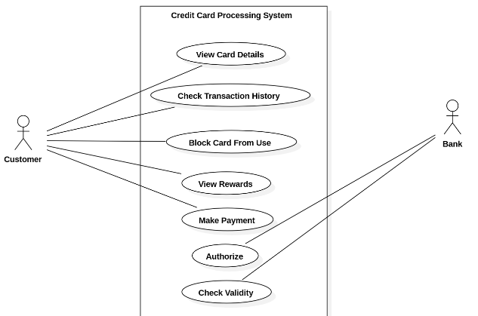

**Fig 2.4.1: Simple Use Case Diagram**

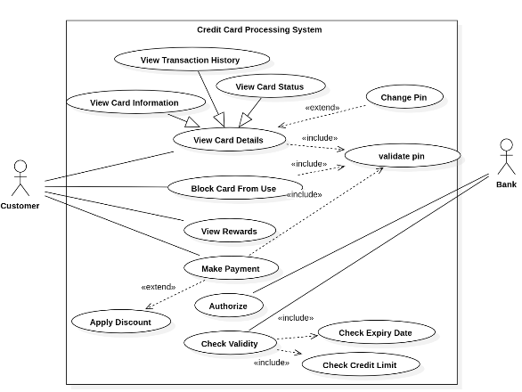

**Fig 2.4.2: Advanced Use Case Diagram**

This use case diagram provides an overview of the interactions between actors (Customer and Bank) and the **Credit Card Processing System**. Key use cases and their relationships are as follows:

**Actors:**

1. **Customer**: Interacts with the system to manage credit card-related tasks.
2. **Bank**: Handles backend validation and credit management processes.

**Use Cases:**

1. **View Card Details**: The customer retrieves information about their credit card.
   * Includes:
     + **Validate PIN**: Ensures the customer is authorized to access card details.
   * Extends:
     + **View Transaction History**: Displays past transactions for the card.
     + **View Card Status**: Shows the current status of the card (e.g., active, blocked).
   * Associated with:
     + **View Rewards**: Displays the reward points earned by the customer.
2. **Block Card From Use**: The customer or bank blocks a card due to loss, theft, or fraud.
   * Includes:
     + **Validate PIN**: Confirms customer identity before blocking the card.
3. **Make Payment**: Allows the customer to process payments using the card.
   * Includes:
     + **Authorize**: Verifies the transaction by checking validity, credit limit, and expiry date.
       - **Check Validity**: Confirms the card’s details.
       - **Check Credit Limit**: Ensures sufficient credit is available.
       - **Check Expiry Date**: Validates that the card is not expired.
   * Extends:
     + **Apply Discount**: Applies eligible discounts to the transaction.
4. **Change PIN**: Enables the customer to modify their credit card PIN.
   * Includes:
     + **Validate PIN**: Ensures security before allowing changes.
5. **Refund Payment**: The system processes refunds for incorrect or canceled transactions.
   * Extends:
     + **Make Payment**: Optional use case to reverse a completed transaction.

**Relationships:**

* **Includes**: Represents essential tasks that are part of a broader use case.
  + Example: Make Payment includes Authorize, which further includes Check Validity, Check Credit Limit, and Check Expiry Date.
* **Extends**: Represents optional or conditional tasks that extend the base use case.
  + Example: Apply Discount extends Make Payment when eligible discounts are available.
  1. **Sequence Diagram**

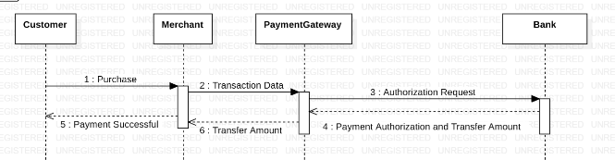

**Fig 2.5.1: Simple Sequence Diagram**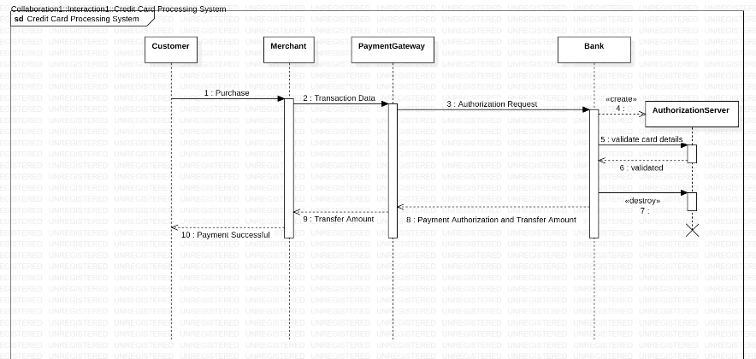

**Fig 2.5.2: Simple Sequence Diagram**

This sequence diagram illustrates the flow of interactions between various components in a **Credit Card Processing System**, namely: Customer, Payment Gateway, Issuer Bank, and Merchant. Here's a detailed breakdown:

**1. Enter Card Details (Customer → Payment Gateway):**

* The customer initiates the transaction by entering their card details into the payment system.

**2. Validate Payment Details (Payment Gateway):**

* The payment gateway validates the provided card details (e.g., card number, expiry date, and CVV).
* If the validation fails, the system displays a **Payment Failure** message to the customer.

**3. Send Request to Issuer Bank (Payment Gateway → Issuer Bank):**

* If the details are valid, the payment gateway sends a request to the issuer bank to check for sufficient credit and authorization.

**4. Check Credit (Issuer Bank → Payment Gateway):**

* The issuer bank verifies the credit limit and authorizes or denies the transaction.
* **If authorized:**
  + The transaction proceeds.
* **If not authorized:**
  + The system sends a **Payment Failure** message to the customer.

**5. Transfer Amount to Merchant (Issuer Bank → Merchant):**

* Upon successful authorization, the issuer bank transfers the amount to the merchant’s account.

**6. Payment Successful (Payment Gateway → Customer):**

* The payment gateway notifies the customer of a successful transaction.

**Additional Details:**

* **Error Handling:**
  + If any step (e.g., validation or credit check) fails, the process halts, and the customer is informed.
* **Final State:**
  + The sequence concludes with either a successful payment confirmation or a failure notification.
  1. **Activity Diagram**

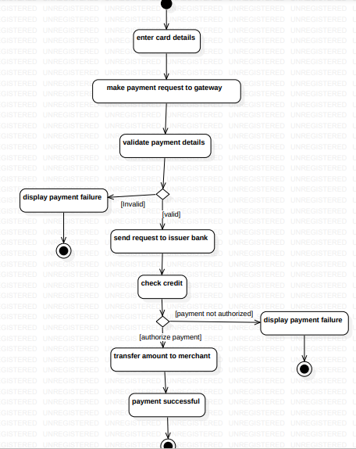

**Fig 2.6.1: Simple Activity Diagram**

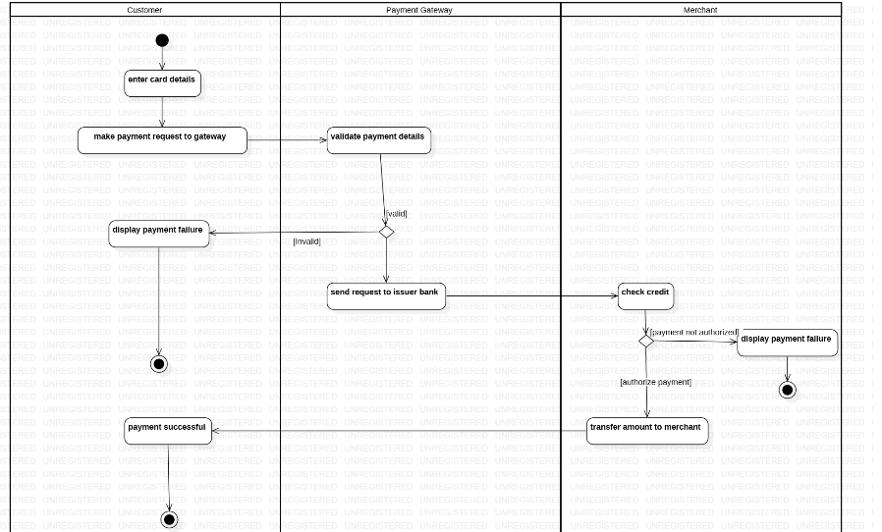

**Fig 2.6.2: Advanced Activity Diagram**

The activity diagram for the **Credit Card Processing System** illustrates the step-by-step workflow of credit card payment processing. Below is the detailed breakdown:

**Start Point:**

* The process begins with the **Customer** entering their card details into the payment system.

**Key Activities:**

1. **Enter Card Details:**
   * The customer provides their card details, including card number, expiry date, and CVV.
2. **Make Payment Request:**
   * The payment request is sent from the customer to the **Payment Gateway**.
3. **Validate Payment Details (Payment Gateway):**
   * The system validates the card details for accuracy and completeness.
   * **Decision Point:**
     + **If valid:** Proceed to send the request to the **Issuer Bank**.
     + **If invalid:** Display **Payment Failure** to the customer and terminate the process.
4. **Send Request to Issuer Bank:**
   * The payment gateway forwards the request to the issuer bank for credit verification and authorization.
5. **Check Credit (Issuer Bank):**
   * The issuer bank verifies if the customer has sufficient credit to process the transaction.
   * **Decision Point:**
     + **If authorized:** Proceed with the payment.
     + **If not authorized:** Inform the **Payment Gateway**, which displays **Payment Failure** to the customer.
6. **Transfer Amount to Merchant (Issuer Bank → Merchant):**
   * If the transaction is authorized, the issuer bank transfers the amount to the merchant’s account.
7. **Confirm Payment:**
   * The **Payment Gateway** notifies the customer of the successful payment transaction.

**Decision Points:**

* **Is Card Valid?**
  + If valid, proceed with sending the request to the issuer bank.
  + If invalid, display payment failure to the customer.
* **Is Payment Authorized?**
  + If authorized, the amount is transferred to the merchant.
  + If not authorized, display payment failure to the customer.

**End Point:**

* The activity concludes when:
  + The payment is successfully processed, and a confirmation is sent to the customer.
  + Alternatively, the process ends with a payment failure notification.

1. **Library Management System**

**Problem Statement**: Managing the operations of a library manually, such as tracking borrowed books, overdue returns, and inventory updates, is time-consuming and prone to errors. A robust system is needed to streamline these operations, improve efficiency, and enhance the experience for library users.

* 1. **SRS-Software Requirements Specification**

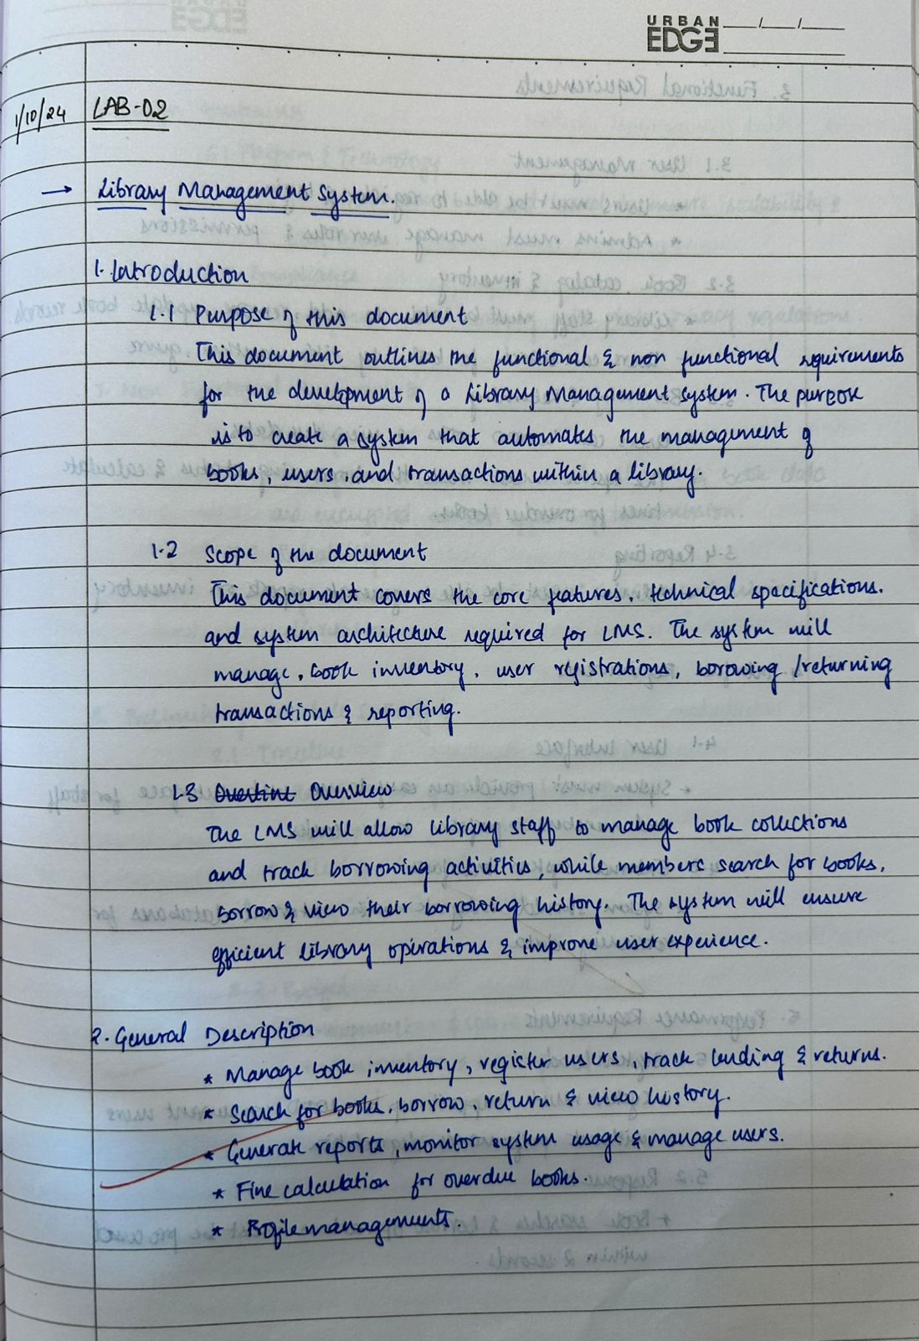

**Fig 3.1.1**

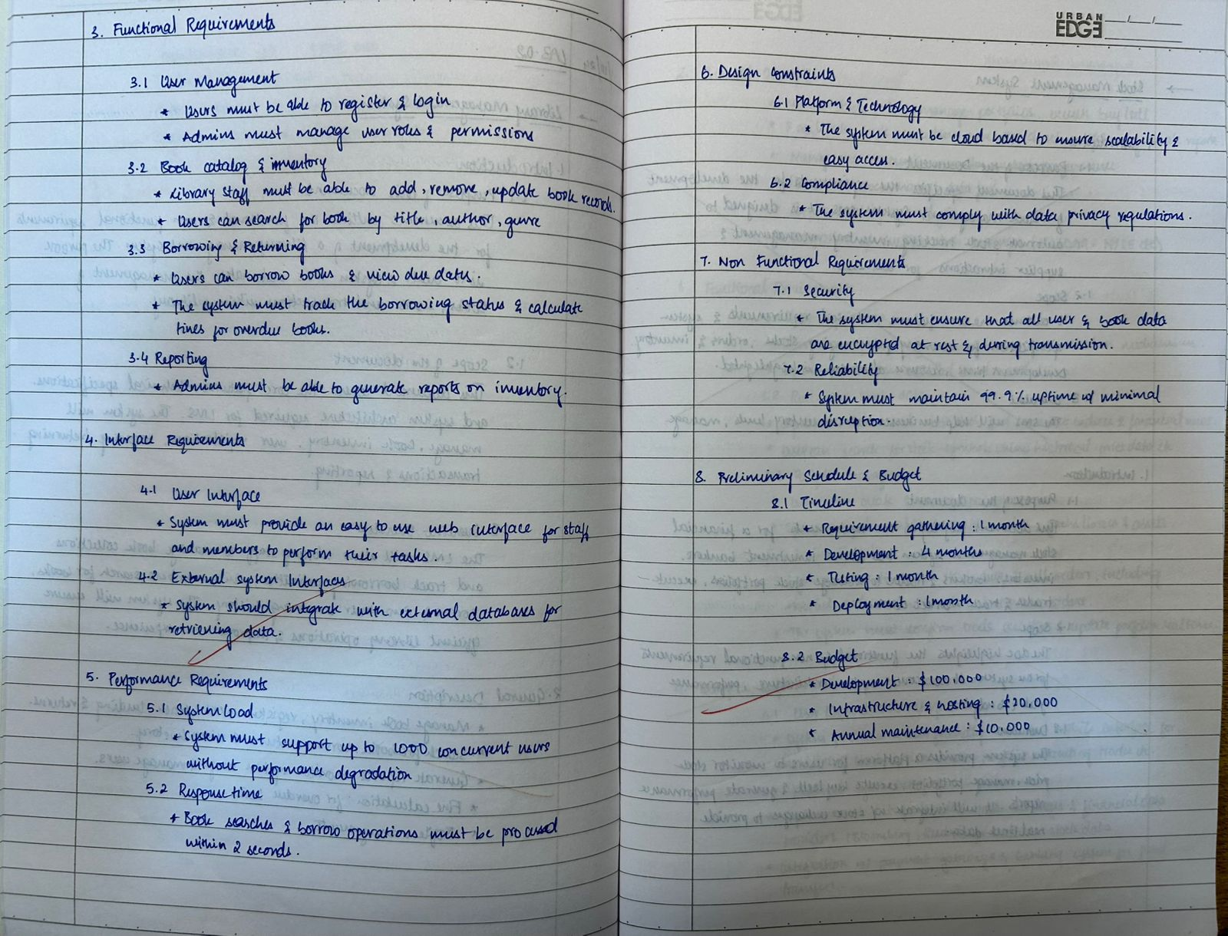

**Fig 3.1.2**

* 1. **Class Diagram**

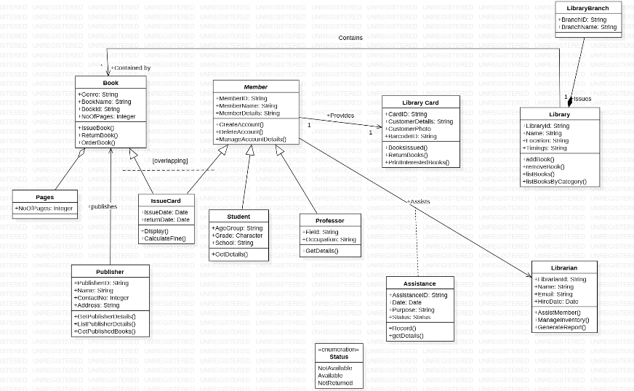

**Fig 3.2.1: Advanced Class Diagram**

**Core Classes:**

1. **Book**: Represents a book in the library with attributes and methods to manage book-related activities.
   * **Attributes**:
     + bookName: Name of the book.
     + bookID: Unique identifier for the book.
     + noOfPages: Total number of pages in the book.
   * **Methods**:
     + IssueBook(): Issues a book to a member.
     + ReturnBook(): Handles the return of a book.
     + OrderBook(): Processes the procurement of a new book.
2. **Member**: Represents a library member with attributes and methods for membership management.
   * **Attributes**:
     + memberID: Unique identifier for the member.
     + membership: Type of membership (e.g., Student, Professor).
     + memberDetails: Additional details about the member.
   * **Methods**:
     + createAccount(): Creates a new member account.
     + deleteAccount(): Deletes an existing member account.
     + manageAccountDetails(): Updates member account details.
3. **LibraryCard**: Represents the library card issued to members.
   * **Attributes**:
     + cardID: Unique ID of the library card.
     + customerDetails: Information about the cardholder.
     + booksIssued: Number of books issued on this card.
   * **Methods**:
     + returnBook(): Facilitates the return of books.
     + printIssuedBooks(): Displays details of books issued on the card.
4. **Library**: Represents the library entity and its operations.
   * **Attributes**:
     + libraryID: Identifier for the library.
     + name: Name of the library.
     + timings: Operational hours of the library.
   * **Methods**:
     + addBook(): Adds a book to the inventory.
     + removeBook(): Removes a book from the inventory.
     + listBooksByCategory(): Displays books based on category.
5. **Publisher**: Represents publishers associated with the library's books.
   * **Attributes**:
     + publisherID: Unique identifier for the publisher.
     + name: Name of the publisher.
     + contactNo: Contact details of the publisher.
   * **Methods**:
     + listPublisherDetails(): Retrieves publisher information.
     + getPublishedBooks(): Lists books published by the publisher.
6. **Librarian**: Represents the librarian managing the library system.
   * **Attributes**:
     + librarianID: Unique ID for the librarian.
     + name: Librarian's name.
     + email: Contact email of the librarian.
   * **Methods**:
     + assistMember(): Assists members with inquiries.
     + manageInventory(): Manages the library's book inventory.
     + generateReport(): Prepares reports on library activities.

**Specialized Entities:**

1. **Student**: Inherits from the Member class, representing student members.
   * **Attributes**:
     + ageGroup: Specifies the student’s age range.
     + grade: Represents the student’s grade.
     + school: Name of the school the student attends.
   * **Methods**:
     + getDetails(): Retrieves details specific to the student.
2. **Professor**: Inherits from the Member class, representing professor members.
   * **Attributes**:
     + field: The professor’s field of expertise.
     + occupation: Designation or role in the institution.
   * **Methods**:
     + getDetails(): Retrieves details specific to the professor.
3. **Assistance**: Represents help provided by the library staff.
   * **Attributes**:
     + date: Date the assistance was provided.
     + purpose: Reason or purpose for the assistance.
   * **Methods**:
     + getDetails(): Provides details about the assistance.
4. **IssueCard**: Tracks the issue and return of books.
   * **Attributes**:
     + issueDate: Date of book issue.
     + returnDate: Expected return date for issued books.
   * **Methods**:
     + display(): Displays issue card details.
     + calculateFine(): Calculates fines for overdue books.
   1. **State Machine Diagram**

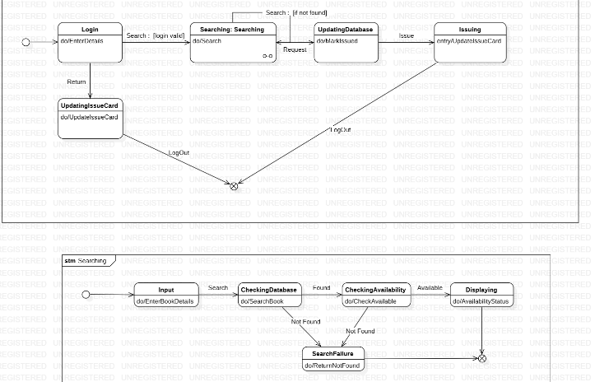

**Fig 3.3.1: Simple State Machine Diagram**

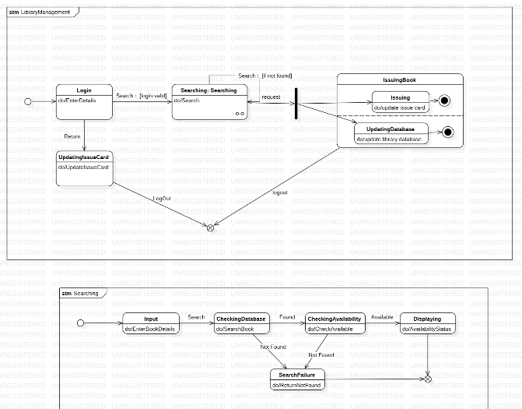

**Fig 3.3.2: Advanced State Machine Diagram**

**State Machine: Book Borrowing**

* **Initial State**: The process begins at the "Request Book" state.
* **Request Book**: Represents the initial step where a library member requests a book.
  + **Actions**: do/request book: Records the book request.
  + **Transitions**:
    - If the book is available, transitions to the "Check Member Eligibility" state.
    - If unavailable, transitions to the "Waitlist Book" state.
* **Check Member Eligibility**: Verifies the borrowing limit and membership validity.
  + **Actions**:
    - do/check borrowing limit.
    - do/validate membership.
  + **Transitions**:
    - If eligible, transitions to the "Issue Book" state.
    - If ineligible (e.g., expired membership), transitions to a termination or retry state.
* **Issue Book**: Issues the requested book to the member.
  + **Actions**:
    - do/update inventory.
    - do/register issued book.
  + **Transitions**: Leads to the "Borrowed" state.
* **Borrowed**: Marks the book as borrowed.
  + **Actions**: do/track due date.
  + **Transitions**: Ends at the final state after the book has been successfully issued.
* **Final State**: Reached upon successful completion of the book borrowing process.

**State Machine: Book Return**

* **Initial State**: The process begins at the "Initiate Return" state.
  + **Action**: do/return book request.
* **Verify Return**: Confirms the details of the returned book.
  + **Actions**:
    - do/check book condition.
    - do/validate return date.
  + **Transitions**:
    - If valid, transitions to the "Process Return" state.
    - If invalid (e.g., damaged book), transitions to the "Fine Calculation" state.
* **Fine Calculation**: Calculates late fees or damage penalties.
  + **Actions**:
    - do/calculate overdue fine.
    - do/calculate damage fee.
  + **Transitions**:
    - If fines are paid, proceeds to the "Process Return" state.
    - If unpaid, allows retry or transitions to a termination state.
* **Process Return**: Updates the inventory and member account details.
  + **Actions**:
    - do/update inventory.
    - do/clear borrowed record.
  + **Transitions**: Leads to the "Returned" state.
* **Returned**: Marks the book as returned.
  + **Actions**: do/notify member of successful return.
  + **Transitions**: Ends at the final state.
* **Final State**: Reached upon successful return of the book.

**State Machine: Membership Management**

* **Initial State**: The process begins at the "Create Account" state.
  + **Action**: do/register member.
* **Validate Details**: Verifies the personal details of the member.
  + **Actions**:
    - do/validate name.
    - do/validate ID proof.
  + **Transitions**:
    - If valid, moves to the "Activate Membership" state.
    - If invalid, transitions to a retry or termination state.
* **Activate Membership**: Activates the membership and generates a library card.
  + **Actions**:
    - do/generate library card.
    - do/update membership database.
  + **Transitions**: Leads to the "Membership Active" state.
* **Membership Active**: Marks the membership as active and ready for use.
  + **Actions**: do/send confirmation to member.
  + **Transitions**: Ends at the final state.
* **Final State**: Reached upon successful activation of the membership.
  1. **Use Case Diagram**

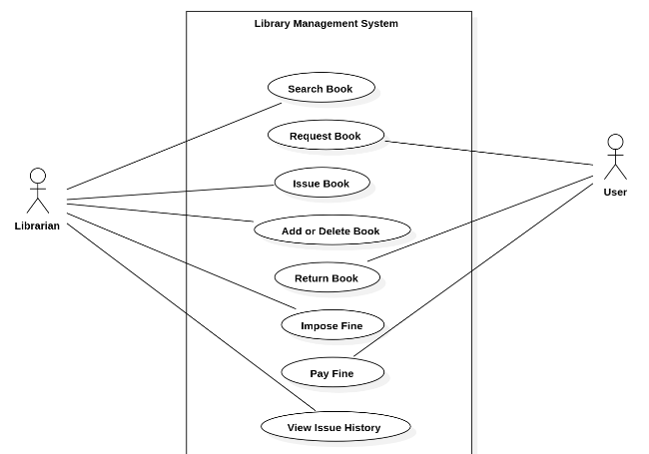

**Fig 3.4.1: Simple Use Case Diagram**

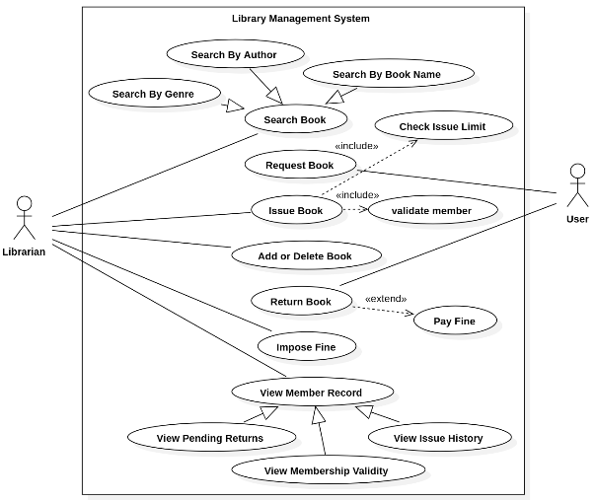

**Fig 3.4.2: Advanced Use Case Diagram**

**Actors:**

1. **Library Member**: Interacts with the system to perform book-related and membership-related activities.
2. **Librarian**: Manages the operational tasks of book lending, returns, and inventory updates.
3. **System Admin**: Oversees system configurations and user account management.

**Use Cases:**

1. **Borrow Book**: The library member borrows a book from the library.
   * **Includes**:
     + **Check Book Availability**: Ensures the requested book is available for borrowing.
     + **Verify Member Eligibility**: Confirms that the member has an active membership and hasn’t exceeded the borrowing limit.
   * **Extends**:
     + **Reserve Book**: Allows the member to reserve the book if unavailable.
   * **Associated with**:
     + **Update Borrow History**: Records the borrowed book in the member's account.
2. **Return Book**: The library member returns a borrowed book to the library.
   * **Includes**:
     + **Verify Return Details**: Checks the book condition and return date.
   * **Extends**:
     + **Calculate Late Fee**: Applies overdue charges if the book is returned after the due date.
     + **Notify Librarian**: Sends a notification to the librarian for any book damage or overdue returns.
3. **Search Catalog**: The library member searches for books in the library database.
   * **Includes**:
     + **Filter Results**: Narrows search results based on genre, author, or publication year.
     + **View Book Details**: Displays details such as availability, location, and a brief summary of the book.
4. **Renew Membership**: Enables the library member to extend their membership validity.
   * **Includes**:
     + **Validate Member Account**: Ensures the account is eligible for renewal.
     + **Process Payment**: Handles the payment process for membership renewal.
5. **Manage Inventory**: Allows the librarian to add, update, or remove books in the library database.
   * **Includes**:
     + **Add New Book**: Registers a new book in the system.
     + **Update Book Details**: Edits book information such as title, author, or availability.
     + **Remove Book**: Deletes outdated or unavailable books from the inventory.
6. **Register Member**: The librarian or system admin registers a new library member.
   * **Includes**:
     + **Validate Member Details**: Ensures that the provided details (e.g., name, ID proof) are accurate.
     + **Generate Membership ID**: Issues a unique membership ID for the new user.
7. **Generate Reports**: Allows the librarian or system admin to create reports on library usage.
   * **Includes**:
     + **Generate Borrowing Statistics**: Summarizes borrowing trends over a specific period.
     + **Generate Overdue Reports**: Lists members with overdue books.

**Relationships:**

* **Includes**: Represents essential tasks that are part of a broader use case.
  + **Example**: Borrow Book includes Check Book Availability and Verify Member Eligibility, both of which are necessary steps.
* **Extends**: Represents optional or conditional tasks that extend the base use case.
  + **Example**: Calculate Late Fee extends Return Book when the book is returned late.
  1. **Sequence Diagram**

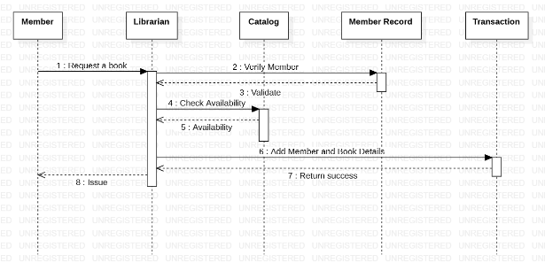

**Fig 3.5.1: Simple Sequence Diagram**

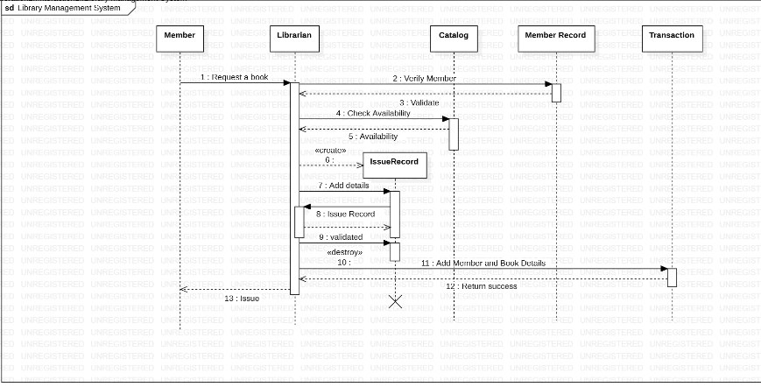

**Fig 3.5.2: Advanced Use Case Diagram**

This sequence diagram illustrates the flow of interactions between various components in a Library Book Borrowing System, namely: **Library Member, Library System, Librarian, and Inventory Database**. Here's a detailed breakdown:

**1. Search for Book Availability (Library Member → Library System):**

* The library member initiates the borrowing process by searching for the desired book in the library system.

**2. Check Book Inventory (Library System → Inventory Database):**

* The library system queries the inventory database to check for the availability of the requested book.
* If the book is unavailable:
  + The system notifies the member of the unavailability and offers the option to reserve the book.
* If the book is available:
  + The process proceeds to the next step.

**3. Borrow Request Initiation (Library Member → Library System):**

* The library member initiates the borrowing request through the system.

**4. Verify Membership (Library System → Librarian):**

* The system notifies the librarian to validate the member's eligibility (e.g., active membership and borrowing limit).
* If the membership is invalid:
  + The librarian informs the member, and the process ends.
* If the membership is valid:
  + The process continues.

**5. Update Inventory and Borrow History (Library System → Inventory Database):**

* Upon successful verification, the library system updates the inventory database to mark the book as borrowed.
* It also records the transaction in the member's borrowing history

**6. Handover Book (Librarian → Library Member):**

* The librarian hands over the physical book to the member, completing the borrowing process.

**Additional Details:**

* **Error Handling:**
  + If any step fails (e.g., the book is unavailable, or the member’s account is invalid), the process halts, and the system informs the member.
* **Final State:**
  + The sequence concludes with either a successful handover of the book or a notification of failure due to unmet conditions.
  1. **Activity Diagram**

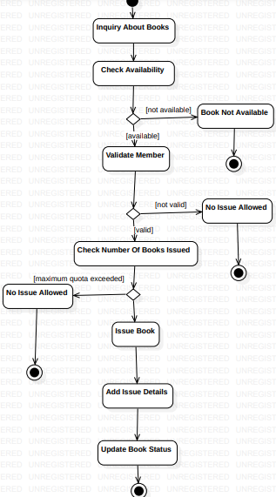

**Fig 3.6.1: Simple Activity Diagram**

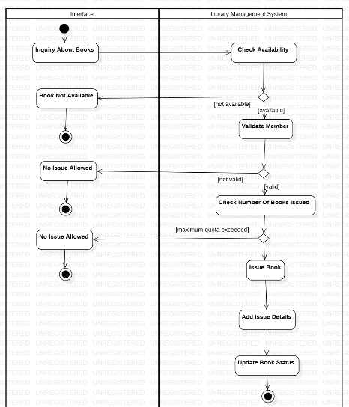

**Fig 3.6.2: Advanced Activity Diagram**

The activity diagram for the Library Book Borrowing System illustrates the step-by-step workflow of borrowing a book. Below is the detailed breakdown:

**Start Point:**

* The process begins when the Library Member initiates a book search in the library system.

**Key Activities:**

1. **Search for Book:**
   * The member searches for the desired book by entering the title or author into the system.
2. **Check Book Availability:**
   * The library system queries the inventory database to determine the book's availability.
3. **Decision Point: Is the Book Available?**
   * **If available:** Proceed to initiate a borrow request.
   * **If not available:** Display a message offering the option to reserve the book.
4. **Initiate Borrow Request:**
   * If the book is available, the member submits a borrow request.
5. **Verify Membership:**
   * The librarian verifies the member’s eligibility (e.g., active membership and borrowing limit).
6. **Decision Point: Is Membership Valid?**
   * **If valid:** Proceed to update inventory and borrowing history.
   * **If invalid:** Display a message rejecting the borrow request and terminate the process.
7. **Update Inventory and Borrow History:**
   * The library system updates the inventory database to mark the book as borrowed.
   * It also logs the transaction in the member’s borrowing history.
8. **Handover Book:**
   * The librarian hands the physical book to the member, completing the borrowing process.

**Decision Points:**

1. **Is the Book Available?**
   * **If yes:** Proceed with the borrowing process.
   * **If no:** Display an option to reserve the book or end the process.
2. **Is Membership Valid?**
   * **If yes:** Allow the borrowing request to proceed.
   * **If no:** Reject the request and terminate the process.

**End Point:**

* The activity concludes when:
  + The book is successfully borrowed, and the member receives the book.
  + Alternatively, the process ends if the book is unavailable or the membership is invalid.

1. **Passport Automation System**

**Problem Statement**: Managing stock levels manually in a business is inefficient, prone to human error, and can lead to overstocking or understocking issues. A well-organized system is required to monitor inventory, track stock movements, and ensure the availability of items to meet customer demands efficiently.

* 1. **SRS-Software Requirements Specification**

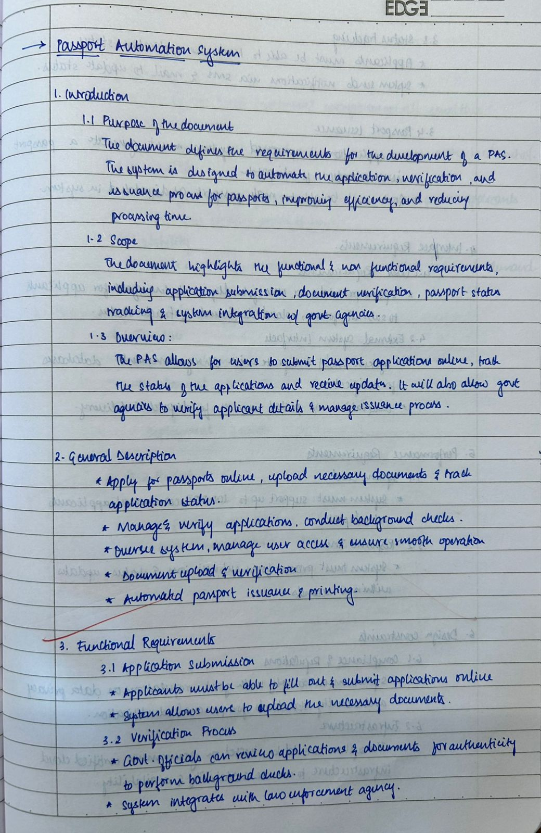

**Fig 4.1.1**

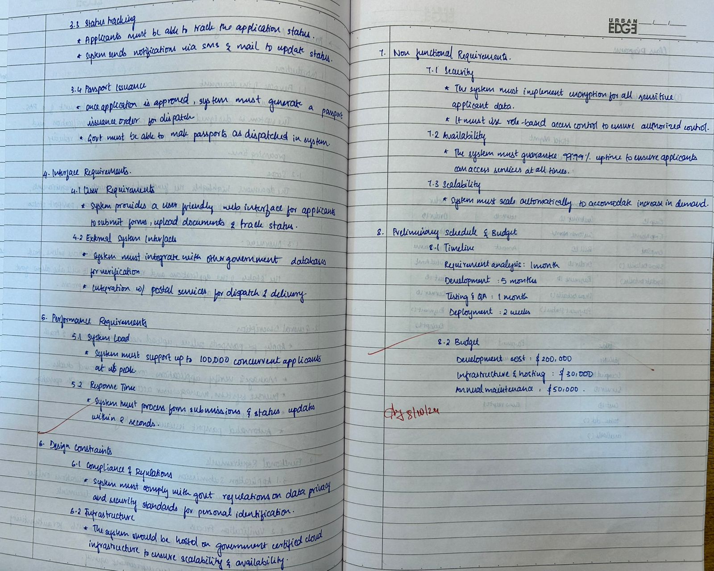

**Fig 4.1.2**

**4.2 Class Diagram**

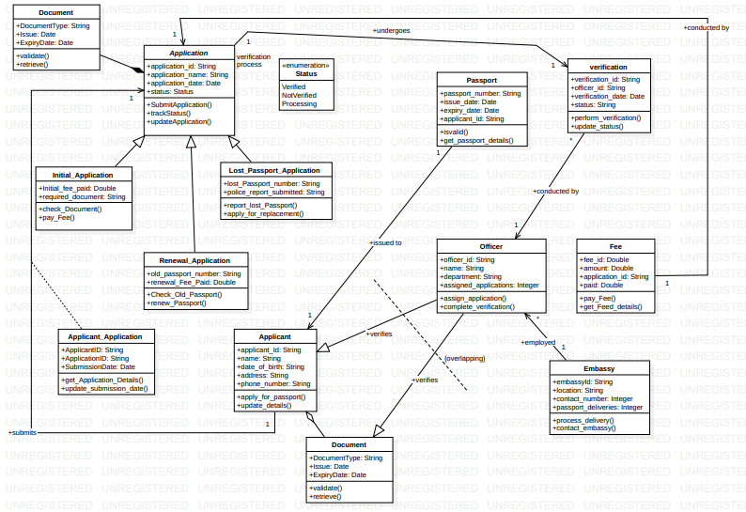

**Fig 4.2.1: Advanced Class Diagram**

The class diagram represents a **Passport Automation System** that encompasses key entities and their interactions. Below are the major elements:

**Core Classes:**

* **Applicant:** Represents the individual applying for a passport. Attributes include:
  + applicant_id (unique ID of the applicant)
  + name, address, contact (applicant details)
  + Methods:
    - apply_for_passport(): Initiates the passport application process.
    - update_details(): Allows the applicant to modify their details.
* **Application:** Manages the passport application process. Attributes include:
  + application_id, status, submission_date, type (type of application: new, renewal, lost).
  + Methods:
    - submit_application(): Records the submission of a passport application.
    - update_application(): Updates application details based on applicant input.
* **Document:** Represents documents submitted for verification. Attributes include:
  + doc_type, issue_date, expiry_date, retrieved (indicates if retrieved).
  + Methods:
    - validate(): Checks the validity of the document.
* **Officer:** Represents the personnel verifying applications. Attributes include:
  + officer_id, name, department.
  + Methods:
    - conduct_verification(): Reviews and validates the application and documents.
    - update_status(): Updates the verification status of an application.
* **Verification:** Tracks the verification process. Attributes include:
  + verification_id, status (e.g., Pending, Verified, Rejected), and date.
  + Methods:
    - update_status(): Modifies the status of verification based on results.
* **Passport:** Represents the finalized passport issued to the applicant. Attributes include:
  + passport_number, issue_date, expiry_date.
  + Methods:
    - validate(): Ensures the passport details comply with requirements.
    - get_passport_details(): Retrieves passport information.

**Specialized Entities:**

* **Fee:** Represents payment information. Attributes include:
  + fee_id, amount, and payment_status.
  + Methods:
    - pay_fee(): Processes application fees.
* **Embassy:** Represents the embassy’s involvement. Attributes include:
  + embassy_id, contact, and address.
  + Methods:
    - process_delivery(): Manages passport delivery to applicants.

**Utility Classes:**

* **Status:** Manages the current state of applications. Attributes include:
  + status_type (e.g., Pending, Approved, Rejected).
  + Methods:
    - check_status(): Retrieves the status of an application.

**Relationships:**

* **Inheritance:**
  + Initial_Application, Renewal_Application, and Lost_Passport_Application inherit from Application.
* **Aggregation:**
  + Applicant aggregates Application and Document, indicating a one-to-many relationship.
* **Dependency:**
  + Verification depends on Officer to conduct the process.
  + Fee depends on Application for payment tracking.
* **Associations:**
  + Applicant is associated with Application through a one-to-many relationship.
  + Passport interacts with Embassy for delivery.

**4.3 State Machine Model**

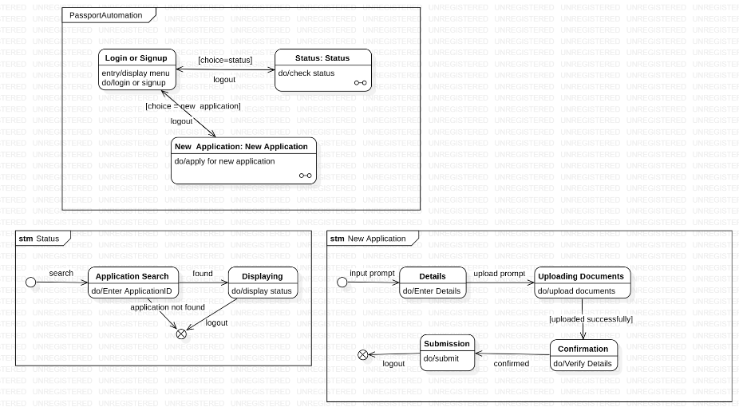

**Fig 4.3.1: Simple State Machine Model**

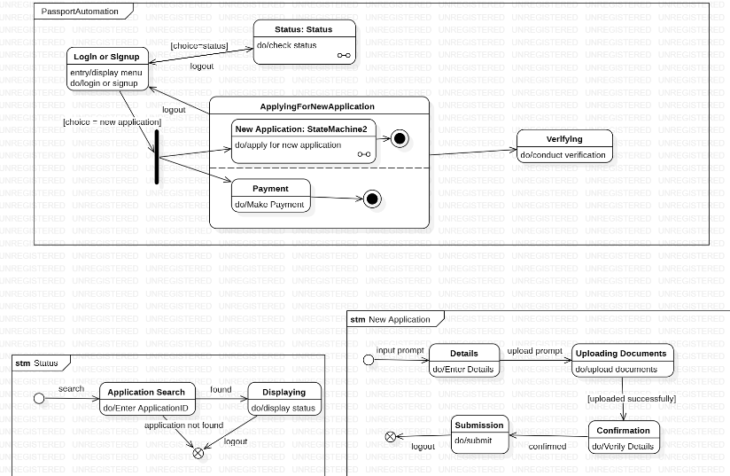

**Fig 4.3.2: Advanced State Machine Model**

**State Machine: Passport Application Process**

* **Initial State:** The process begins at the **Application Submission** state.
* **Application Submission:** Represents the initial step of submitting the passport application.
  + **Actions:**
    - do/submit application: Records applicant details and application type.
  + **Transitions:**
    - Moves to the **Verification** state after submission.
* **Verification:** Ensures that the documents and application details are valid.
  + **Actions:**
    - do/verify documents: Reviews submitted documents.
    - do/check application details: Confirms the accuracy of applicant details.
  + **Transitions:**
    - If all documents are valid, transitions to the **Approval** state.
    - If documents are invalid, transitions to the **Correction** state.
* **Correction:** Allows applicants to update and resubmit details.
  + **Actions:**
    - do/request corrections: Informs applicants of required changes.
    - do/accept revised documents: Records resubmitted information.
  + **Transitions:**
    - If updated successfully, transitions back to the **Verification** state.
* **Approval:** The application is reviewed for final approval.
  + **Actions:**
    - do/review application: Conducts final checks by the officer.
  + **Transitions:**
    - If approved, moves to the **Fee Payment** state.
    - If rejected, transitions to a **Rejection** or **Termination** state.
* **Fee Payment:** Represents the payment of application fees.
  + **Actions:**
    - do/pay application fee: Processes payment for the application.
  + **Transitions:**
    - If successful, transitions to the **Passport Issuance** state.
    - If unsuccessful, allows retry or moves to a **Termination** state.
* **Passport Issuance:** Represents the printing and issuance of the passport.
  + **Actions:**
    - do/print passport: Generates the passport.
    - do/deliver passport: Sends the passport to the applicant.
  + **Final State:** Reached after the passport is successfully issued.

**State Machine: Document Verification**

* **Initial State:** Starts with the **Document Submission** state.
  + **Action:**
    - do/submit documents: Receives necessary documents for verification.
* **Validation:** Reviews each document for compliance and validity.
  + **Actions:**
    - do/validate ID proof: Confirms the authenticity of ID proof.
    - do/verify address proof: Ensures address details are accurate.
  + **Transitions:**
    - If all documents are valid, moves to the **Verification Completed** state.
    - If any document is invalid, transitions to **Correction Requested.**
* **Correction Requested:** Requests the applicant to correct and resubmit documents.
  + **Actions:**
    - do/request corrections: Indicates required changes.
  + **Transitions:**
    - If corrected successfully, returns to the **Validation** state.
* **Verification Completed:**
  + Represents the final state of document verification.

**State Machine: Passport Delivery Process**

* **Initial State:** Begins with the **Passport Dispatch** state.
  + **Action:**
    - do/dispatch passport: Sends the passport to the designated address.
* **In Transit:** Tracks the delivery process.
  + **Action:**
    - do/track delivery: Monitors the status of passport delivery.
  + **Transitions:**
    - If delivered, moves to the **Delivery Confirmed** state.
    - If delivery fails, transitions to **Reattempt Delivery.**
* **Reattempt Delivery:** Attempts to resolve delivery issues.
  + **Actions:**
    - do/verify address: Confirms the recipient’s details.
    - do/schedule reattempt: Plans a new delivery attempt.
  + **Transitions:**
    - If successful, moves to the **Delivery Confirmed** state.
    - If unsuccessful, transitions to **Termination.**
* **Delivery Confirmed:**
  + The final state, reached upon successful delivery of the passport.

**4.4 Use Case Diagram**

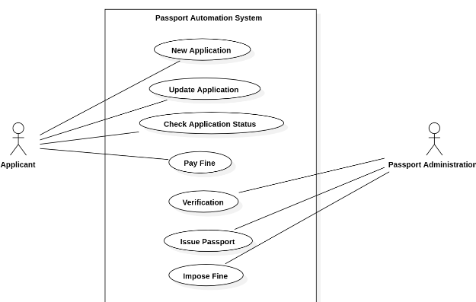

**Fig 4.4.1: Simple Use Case Diagram**

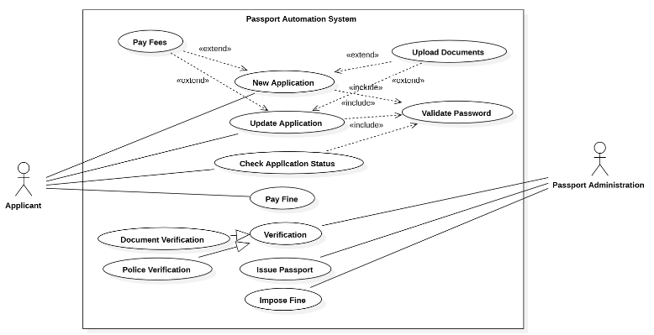

**Fig 4.4.2: Advanced State Machine Model**

**Actors:**

1. **Applicant:** Submits the application, tracks the status, and provides required details.
2. **Passport Authority:** Manages document verification, approval, and issuance of passports.

**Use Cases:**

1. **Submit Application:** The applicant submits the passport application.
   * **Includes:**
     + Validate Application Details: Ensures all required details are provided.
     + Validate Documents: Confirms that uploaded documents meet the required format.
   * **Extends:**
     + Track Application Status: Allows applicants to monitor their application's progress.
2. **Verify Documents:** The passport authority reviews submitted documents for accuracy.
   * **Includes:**
     + Validate ID Proof: Confirms the authenticity of identity documents.
     + Validate Address Proof: Verifies the applicant's address details.
   * **Extends:**
     + Request Corrections: Initiated if the submitted documents are invalid.
3. **Approve Application:** The passport authority approves valid applications.
   * **Includes:**
     + Review Application: Conducts a final review of the application.
     + Issue Approval Letter: Provides official confirmation to the applicant.
4. **Make Payment:** The applicant pays the required application fee.
   * **Includes:**
     + Validate Payment Details: Checks for accurate payment credentials.
   * **Extends:**
     + Retry Payment: Optional use case for unsuccessful transactions.
5. **Issue Passport:** The passport authority issues the passport after approval.
   * **Includes:**
     + Generate Passport: Prepares the physical or digital passport.
     + Dispatch Passport: Sends the passport to the applicant.
   * **Extends:**
     + Track Delivery: Allows applicants to monitor the delivery status.
6. **Track Application Status:** The applicant tracks the progress of their application.
   * **Includes:**
     + Check Verification Status: Provides updates on document verification.
     + Check Approval Status: Displays the final decision on the application.
7. **Request Corrections:** The applicant corrects and resubmits invalid application details.
   * **Includes:**
     + Edit Application Details: Allows updates to submitted information.
     + Reupload Documents: Facilitates resubmission of corrected documents.
   * **Extends:**
     + Submit Application: The revised details are resubmitted for review.

**4.5 Sequence Diagram**

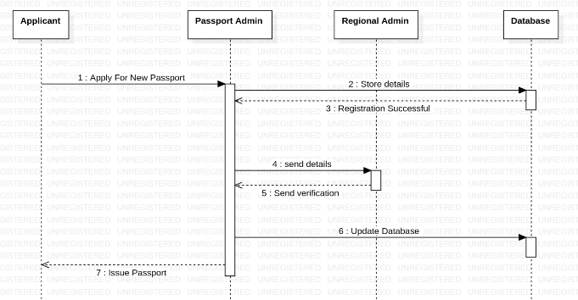

**Fig 4.5.1: Simple Sequence Diagram**

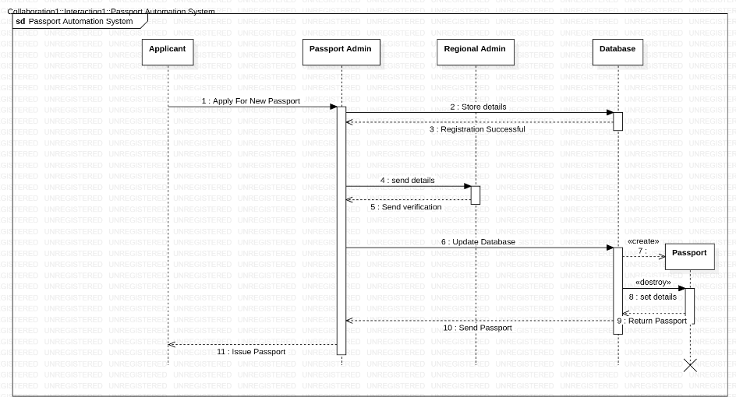

**Fig 4.5.2: Advanced Sequence Diagram**

This sequence diagram illustrates the flow of interactions between various components in the Passport Automation System, namely: Applicant, System, Passport Authority, and Delivery Service. Here's a detailed breakdown:

1. **Submit Application (Applicant → System):**
   * The applicant initiates the process by submitting the passport application through the system.
2. **Validate Application Details (System):**
   * The system validates the provided details, ensuring completeness and format compliance.
   * **If validation fails:**
     + The system notifies the applicant to correct and resubmit the application.
3. **Upload Documents (Applicant → System):**
   * After successful validation, the applicant uploads the required supporting documents (e.g., ID proof, address proof).
4. **Verify Documents (System → Passport Authority):**
   * The system forwards the application and documents to the Passport Authority for verification.
   * **If verification fails:**
     + The system sends a notification to the applicant to correct or resubmit the required documents.
5. **Approve Application (Passport Authority → System):**
   * The Passport Authority reviews and approves the verified application.
   * **If the application is rejected:**
     + The system notifies the applicant with reasons for rejection and next steps.
6. **Make Payment (Applicant → System):**
   * The applicant makes the required payment through the system.
   * **If payment fails:**
     + The system allows the applicant to retry the transaction.
7. **Generate Passport (System → Passport Authority):**
   * After successful payment, the Passport Authority generates the passport.
8. **Dispatch Passport (Passport Authority → Delivery Service):**
   * The Passport Authority forwards the generated passport to the delivery service for dispatch.
9. **Track Delivery (Applicant → System):**
   * The applicant tracks the delivery status of the passport using the system.
10. **Passport Delivered (Delivery Service → Applicant):**

* The delivery service completes the process by delivering the passport to the applicant.

**Additional Details:**

* **Error Handling:**
  + If any step (e.g., application validation, document verification, or payment) fails, the system halts the process and notifies the applicant for resolution.
* **Final State:**
  + The sequence concludes with either successful passport delivery or resolution of errors.

**4.6 Activity Diagram**

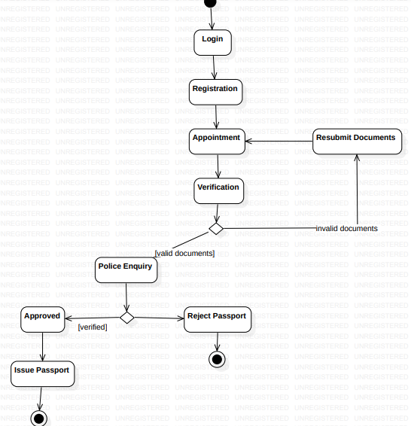

**Fig 4.6.1: Simple Activity Diagram**

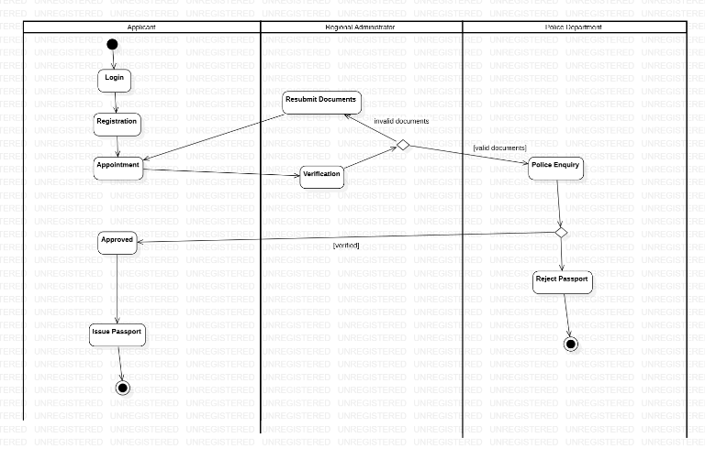

**Fig 4.6.2: Advanced Activity Diagram**

The activity diagram for the Passport Automation System illustrates the step-by-step workflow of passport application, processing, and delivery. Below is the detailed breakdown:

**Start Point:**

* The process begins with the applicant initiating the passport application.

**Key Activities**

1. **Initiate Application:**
   * The applicant starts by filling out the application form online.
2. **Submit Application:**
   * The completed application is submitted through the system.
3. **Validate Application Details (System):**
   * The system validates the submitted details for completeness and accuracy.
   * **Decision Point:**
     + **If valid:** Proceed to document upload.
     + **If invalid:** Notify the applicant and terminate the process until corrected.
4. **Upload Documents:**
   * The applicant uploads required documents such as ID proof, address proof, and photographs.
5. **Verify Documents (System → Passport Authority):**
   * The system forwards the documents to the Passport Authority for verification.
   * **Decision Point:**
     + **If verified:** Proceed to application approval.
     + **If rejected:** Notify the applicant to resubmit correct documents.
6. **Approve Application (Passport Authority):**
   * The Passport Authority reviews and approves the application after verification.
   * **Decision Point:**
     + **If approved:** Proceed to payment.
     + **If rejected:** Notify the applicant with reasons for rejection.
7. **Make Payment (Applicant):**
   * The applicant makes the payment for the passport processing fee.
   * **Decision Point:**
     + **If payment successful:** Proceed to passport generation.
     + **If failed:** Allow the applicant to retry.
8. **Generate Passport (Passport Authority):**
   * The Passport Authority generates the passport after payment confirmation.
9. **Dispatch Passport (Passport Authority → Delivery Service):**
   * The generated passport is dispatched to the applicant’s address through the delivery service.
10. **Track Delivery (Applicant):**

* The applicant can track the passport delivery status via the system.

1. **Deliver Passport (Delivery Service → Applicant):**

* The delivery service delivers the passport to the applicant’s registered address.

**Decision Points:**

1. **Is Application Valid?**
   * If valid, proceed to document upload.
   * If invalid, notify the applicant to make corrections.
2. **Are Documents Verified?**
   * If verified, proceed to application approval.
   * If rejected, notify the applicant for resubmission.
3. **Is Payment Successful?**
   * If successful, proceed to passport generation.
   * If failed, allow retry.

**End Point:**

* The activity concludes when:
  + The passport is successfully delivered to the applicant.
  + Alternatively, the process ends with the applicant being notified of a failure or rejection at any stage.

1. **Stock Management System**

**Problem Statement**: Managing stock transactions manually in a stock trading system is inefficient, prone to human error, and can lead to delays, incorrect transactions, or missed opportunities. A well-organized system is required to monitor stock availability, validate user actions, track transactions, and ensure seamless buying and selling of stocks to meet user demands efficiently.

**5.1 SRS-Software Requirements Specification**

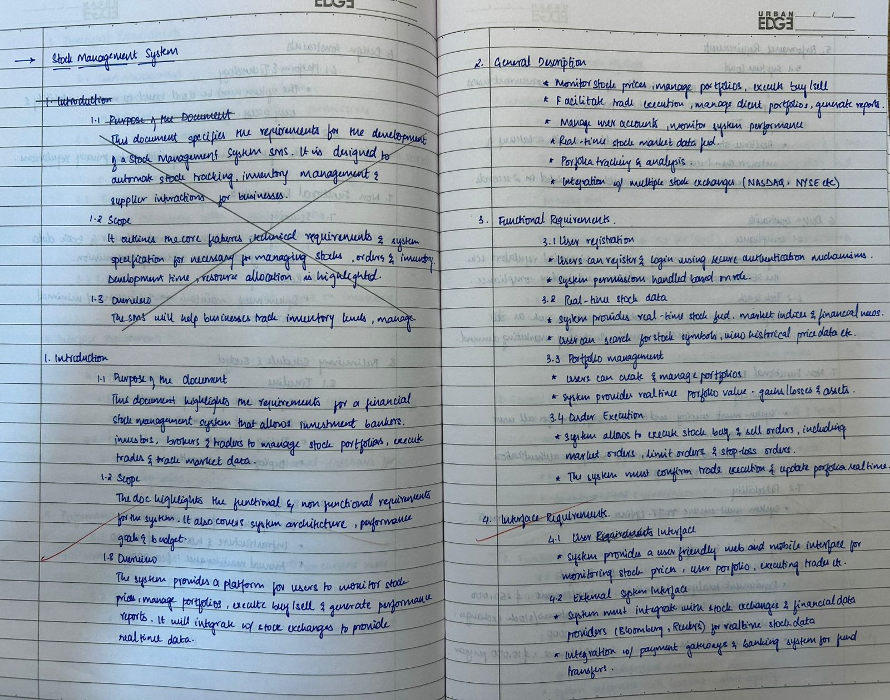

**Fig 5.1.1**

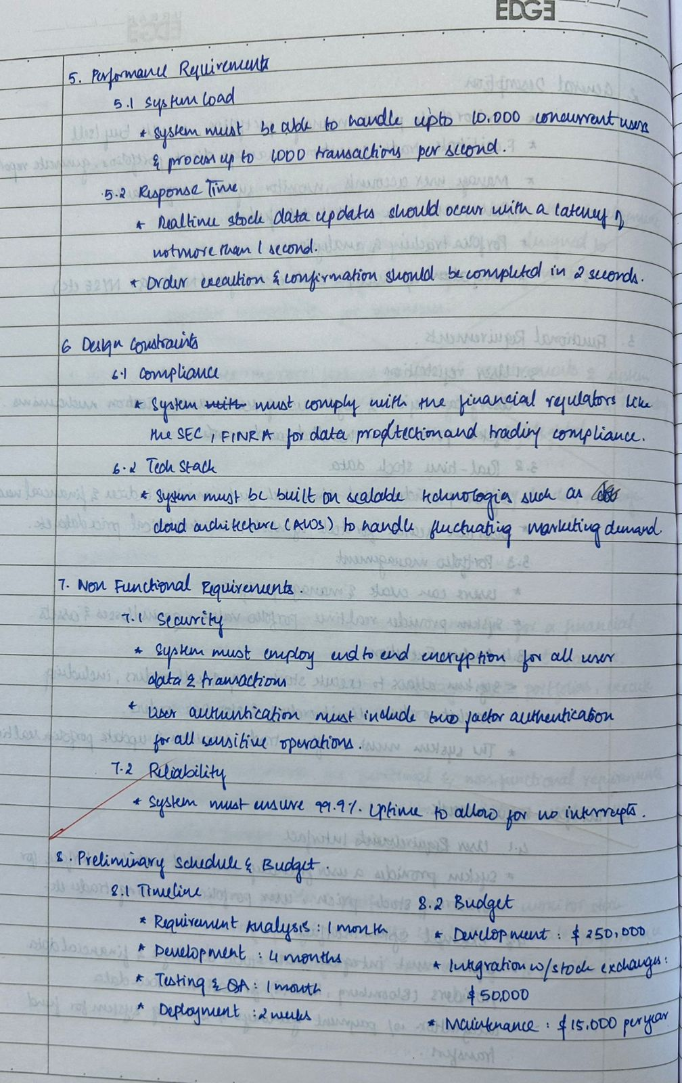

**Fig 5.1.2**

**5.2 Class Diagram**

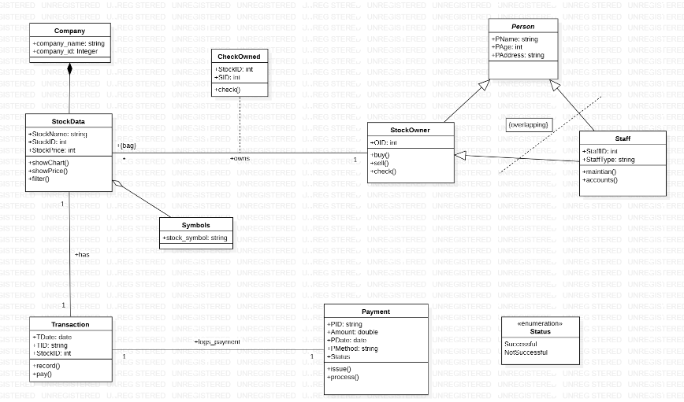

**Fig 5.2.1: Advanced Class Diagram**

The class diagram represents a Stock Management System, outlining key entities and their interactions. Below are the major components:

**Core Classes:**

* **StockManagement**: Manages high-level operations with attributes like StockName, NoOfEmployees, and Location. The Open() method initializes stock management operations.
* **Booking**: Handles reservations with attributes like BookingId, NoOfStocks, CheckIn, and CheckOut, and methods book() and cancel(). Linked to Customer and associated with Stocks.
* **Stocks**: Represents stocks with properties such as StockId, Type, StockNo, and Cost. Aggregates Brokers to define stock structure.
* **Payment**: Tracks payment details using attributes like PaymentId and Status (enumeration: Confirmed, NotConfirmed, Processing) and methods confirmPayment() and cancelPayment().
* **Invoice**: Stores billing information (InvoiceId, Bill) and generates an invoice view using the display() method.

**Specialized Entities:**

* **Person**: Base class for Employee and Customer.
* **Employee**: Adds EmployeeId and Salary.
* **Customer**: Includes CustomerId and is linked to Booking.
* **StockChain**: Represents a chain of stocks with attributes StockName, ChainID, and NoOfStocks. Methods AddStock() and RemoveStock() manage the chain.

**Utility Classes and Enumeration:**

* **Brokers, AC, TV**: Support stock features, e.g., Brokers defines NoOfBrokers and BrokerSize.
* **Status**: Enumerates payment states (e.g., Confirmed, NotConfirmed).

**5.3 State Machine Model**

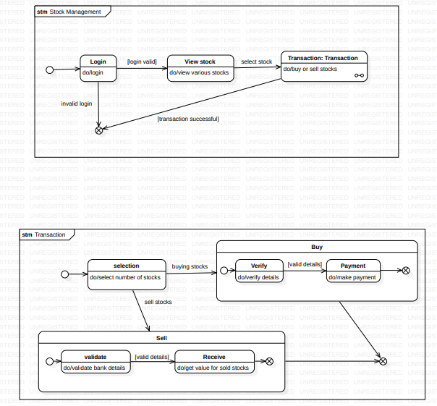

**Fig 5.3.1: Advanced State Machine Model**

The state machine diagrams illustrate the dynamic behavior and transitions between states in the Stock Management System. The key models include the Stock Management, Payment Process, and Transaction Process.

**State Machine: Stock Management**

• **Initial State**: The process begins at the Login state. • **Login**: Handles user authentication, allowing users to log in or sign up. • **ViewStock**: A composite state with operations to view various stocks.

* **Actions**: do/view various stocks
* **Transitions**: If login is valid, the state transitions to ViewStock.
* **Invalid Login**: If the login is invalid, it transitions back to Login. • **Transaction**: A composite state with operations to buy or sell stocks.
* **Actions**: do/buy or sell stocks
* **Transitions**: When a stock is selected, it transitions to Transaction. • **Completion**: The final state is reached after a successful transaction.
* **Actions**: [transaction successful]

**State Machine: Payment Process**

• **Initial State**: Begins with selecting a Payment method.

* **Actions**: do/select payment method • **Verify**: Confirms payment details for accuracy.
* **Actions**: do/verify payment details
* **Transitions**:
  + If verification is successful, transitions to Make Payment.
  + If verification fails, users can retry verification. • **Make Payment**: Requires entering credentials for payment authorization.
* **Actions**: do/make payment
* **Transitions**:
  + **Transaction Success**: Proceeds to the final state, marking payment completion.
  + **Transaction Failure**: Redirects users to retry or cancel the payment. • **Final State**: The process concludes when the payment is completed successfully.

**State Machine: Transaction Process**

• **Initial State**: Begins with Selection.

* **Actions**: do/select number of stocks • **Buy**: A composite state for buying stocks.
* **Verify**: Verifies details before making payment.
  + **Actions**: do/verify details
  + **Transitions**: If verification is successful, transitions to Payment.
* **Payment**: Makes payment for selected stocks.
  + **Actions**: do/make payment
  + **Transitions**: If payment is successful, the transaction is completed. • **Sell**: A composite state for selling stocks.
* **Validate**: Validates bank details before proceeding.
  + **Actions**: do/validate bank details
  + **Transitions**: If validation is successful, transitions to Receive.
* **Receive**: Gets the value for sold stocks.
  + **Actions**: do/get value for sold stocks
  + **Transitions**: If the value is received successfully, the transaction is completed.
  + **Final State**: The process concludes when the transaction (buying or selling) is completed successfully.

**5.4 Use Case Diagram**

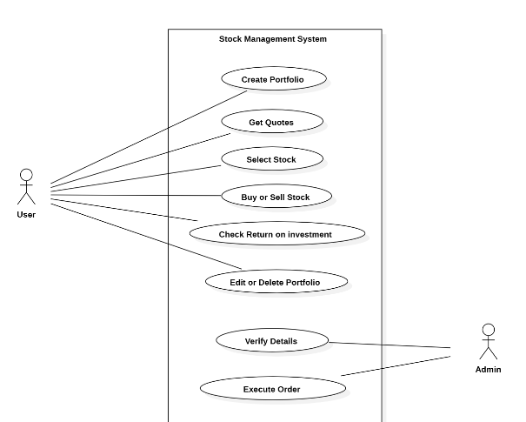

**Fig 5.4.1: Simple Use Case Diagram**

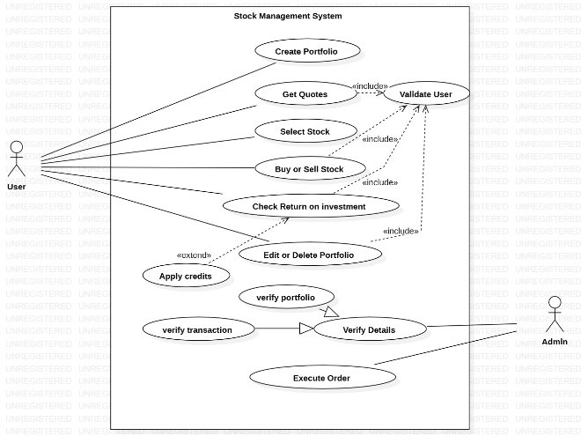

**Fig 5.4.2: Advanced Use Case Diagram**

This use case diagram illustrates the interactions between actors (User and Admin) and the stock management system. Key use cases and their relationships are outlined below:

**Actors:**

1. **User**: Interacts with the system to manage stock transactions and related activities.
2. **Admin**: Handles administrative tasks and validates user actions.

**Use Cases:**

1. **Create Portfolio**: Users can create a portfolio for managing their stocks.
2. **Get Quotes**: Users can retrieve stock quotes.
3. **Select Stock**: Users can select specific stocks to buy or sell.
4. **Buy or Sell Stock**: Users can execute transactions to buy or sell stocks.
5. **Check Return on Investment**: Users can check the returns on their investments.
6. **Edit or Delete Portfolio**: Allows users to modify or delete their portfolio.
   * **Includes**: Validate User to ensure authorization for editing or deleting.
7. **Apply Credits**: Users can apply credits to their account.
   * **Extends**: Edit or Delete Portfolio for updating credit information.
8. **Verify Portfolio**: Ensures that the portfolio details are correct.
   * **Includes**: Verify Details for accuracy.
9. **Verify Transaction**: Verifies the details of a stock transaction.
10. **Execute Order**: Admins can execute stock orders on behalf of the users.
11. **Verify Details**: Admins can verify user and transaction details for accuracy.
    * **Includes**: Validate User to confirm authorization.

**5.5 Sequence Diagram**

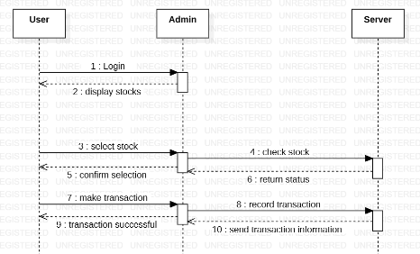

**Fig 5.5.1: Simple Sequence Diagram**

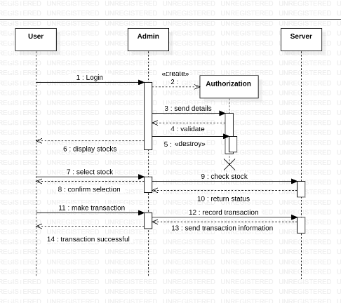

**Fig 5.5.2: Advanced Sequence Diagram**

This sequence diagram details the interactions between key components in the stock management system: User, Admin, Authorization, and Server. Below is the step-by-step flow:

1. **Login (User → Admin)**: The user initiates the process by logging into the system.
2. **Send Details (Admin → Authorization)**: The admin sends the user's login details to the authorization component.
3. **Validate (Authorization → Admin)**: The authorization component validates the user's login details.
4. **Destroy (Authorization)**: After validation, the authorization component destroys the session data.
5. **Display Stocks (Admin → User)**: The admin displays the available stocks to the user.
6. **Select Stock (User → Admin)**: The user selects a stock from the list.
7. **Confirm Selection (Admin → Server)**: The admin sends the stock selection details to the server for confirmation.
8. **Check Stock (Server → Admin)**: The server checks the availability of the selected stock.
9. **Return Status (Server → Admin)**: The server returns the stock status to the admin.
10. **Make Transaction (User → Admin)**: The user initiates the transaction for the selected stock.
11. **Record Transaction (Admin → Server)**: The admin sends the transaction details to the server to record the transaction.
12. **Send Transaction Information (Server → Admin)**: The server sends the recorded transaction information back to the admin.
13. **Transaction Successful (Admin → User)**: The admin notifies the user that the transaction was successful.

**5.6 Activity Diagram**

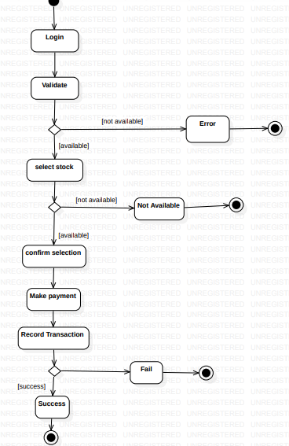

**Fig 5.6.1: Simple Activity Diagram**

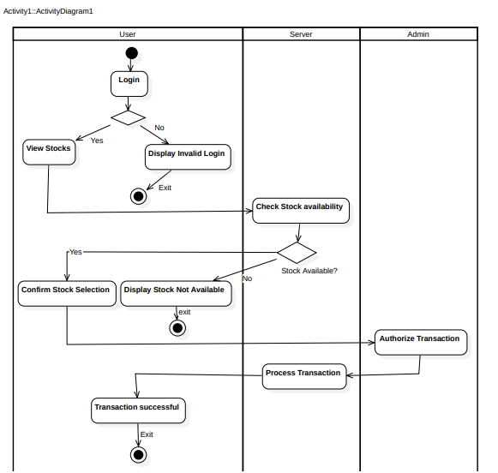

**Fig 5.6.2: Advanced Activity Diagram**

The activity diagram for the Stock Management System illustrates the step-by-step workflow of stock selection, validation, and transaction processing. Below is the detailed breakdown:

**Start Point:**

* The process begins with the user logging into the system.

**Key Activities**

1. **Login:**
   * The user attempts to log in to the system.
   * **Decision Point:**
     + If the login is valid, the user proceeds to the next step.
     + If the login is invalid, the system displays an "Invalid Login" message, and the process terminates.
2. **View Stocks:**
   * Once logged in, the user views the available stocks in the system.
3. **Check Stock Availability (Server):**
   * The system checks if the selected stock is available for transaction.
   * **Decision Point:**
     + If the stock is available, the user can proceed.
     + If not, the system displays "Stock Not Available," and the process ends.
4. **Confirm Stock Selection:**
   * The user confirms the selected stock for the transaction.
5. **Authorize Transaction (Admin):**
   * The admin verifies and authorizes the transaction for the selected stock.
6. **Process Transaction (Server):**
   * The system processes the authorized transaction, ensuring the data is recorded securely.
7. **Transaction Successful:**
   * The system displays a confirmation of the successful transaction to the user.

**Decision Points:**

1. **Is Login Valid?**
   * If valid, proceed to viewing stocks.
   * If invalid, display "Invalid Login."
2. **Is Stock Available?**
   * If available, proceed to confirmation.
   * If unavailable, notify the user and terminate.

**End Point:**

* The process concludes successfully when the transaction is completed, or it terminates prematurely if the login is invalid, or the stock is unavailable.